Value addition to local Kani tribal knowledge: patenting, licensing and benefit-sharing

Abstract

The subject of this case study is the role of intellectual property rights in the benefit-sharing arrangements concerning the “Jeevani” drug, which was developed by scientists at the Tropical Botanic Garden and Research Institute (TBGRI), based on the tribal medicinal knowledge of the Kani tribe in Kerala, South India. “Jeevani” is a restorative, immuno-enhancing, anti-stress and anti-fatigue agent, based on the herbal medicinal plant arogyapaacha, used by the Kani tribals in their traditional medicine. Within the Kani tribe the customary rights to transfer and practice certain traditional medicinal knowledge are held by tribal healers, known as Plathis. The knowledge was divulged by three Kani tribal members to the Indian scientists who isolated 12 active compounds from arogyapaacha, developed the drug “Jevaani”, and filed two patent applications on the drug (and another patent based on the same plant but for different use). The technology was then licensed to the Arya Vaidya Pharmacy, Ltd., an Indian pharmaceutical manufacturer pursuing the commercialization of Ayurvedic herbal formulations. A Trust Fund was established to share the benefits arising from the commercialization of the TK-based drug “Jevaani”. The operations of the Fund with the involvement of all relevant stakeholders, as well as the sustainable harvesting of the arogyapaacha plant, have posed certain problems which offer lessons on the role of intellectual property rights in benefit-sharing over medicinal plant genetic resources and traditional medicinal knowledge.

This is a part of WIPO sponsored study on the role of intellectual property rights in the sharing of benefits arising from the use of biological resources and associated traditional knowledge.

Case Study Two
India

Case Study Two: India

Value addition to local Kani tribal knowledge: patenting, licensing and benefit-sharing

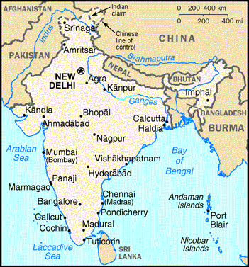

Overview
The subject of this case study is the role of intellectual property rights in the benefit-sharing arrangements concerning the “Jeevani” drug, which was developed by scientists at the Tropical Botanic Garden and Research Institute (TBGRI), based on the tribal medicinal knowledge of the Kani tribe in Kerala, South India. “Jeevani” is a restorative, immuno-enhancing, anti-stress and anti-fatigue agent, based on the herbal medicinal plant arogyapaacha, used by the Kani tribals in their traditional medicine. Within the Kani tribe the customary rights to transfer and practice certain traditional medicinal knowledge are held by tribal healers, known as Plathis. The knowledge was divulged by three Kani tribal members to the Indian scientists who isolated 12 active compounds from arogyapaacha, developed the drug “Jevaani”, and filed two patent applications on the drug (and another patent based on the same plant but for different use). The technology was then licensed to the Arya Vaidya Pharmacy, Ltd., an Indian pharmaceutical manufacturer pursuing the commercialization of Ayurvedic herbal formulations. A Trust Fund was established to share the benefits arising from the commercialization of the TK-based drug “Jevaani”. The operations of the Fund with the involvement of all relevant stakeholders, as well as the sustainable harvesting of the arogyapaacha plant, have posed certain problems which offer lessons on the role of intellectual property rights in benefit-sharing over medicinal plant genetic resources and traditional medicinal knowledge.

Policy Context

A. CBD / UNCCD / TRIPS Agreement

The objectives of the Convention on Biological Diversity (CBD) include the conservation of biodiversity, its sustainable use, and the fair and equitable sharing of the benefits resulting from such use. The CBD recognizes that the authority to determine access to genetic resources rests with national governments and is subject to national legislation, but it is silent about the ownership or property rights of these resources. Article 15(4) of the CBD requires access to resources on mutually agreed terms. Article 15(5) of the CBD requires the prior informed consent of the Contracting Parties while accessing biodiversity. Article 8(j) provides that the knowledge, innovations and practices of indigenous and local communities relevant to biodiversity conservation and utilization should be respected, preserved and maintained. It further obliges Contracting Parties to promote the wider application of such traditional knowledge with the approval and involvement of the holders and to encourage the equitable sharing of the benefits arising from the utilization of the knowledge. Article 15(6), 15(7), 16, 19(1), and 19(2), advocate fair and equitable benefit-sharing arrangements between the providers and users of relevant resources. There are other international instruments which have a bearing on the options of Contracting Parties to explore economic opportunities through the sustainable extraction of, and value addition to, biological resources.

The Agreement on Trade-Related Aspects of Intellectual Property Rights (TRIPS) provides, inter alia, minimum standards for the protection of patents in all fields of technology. This includes the field of biotechnology, where biotechnological inventions utilize biological and genetic resources in new, non-obvious and industrially applicable ways. Such inventions may be conceived with or without the use of traditional knowledge associated with the genetic resources.

Parties to the CBD are obliged to take legislative, administrative and policy measures with the aim to conserve biodiversity and also to ensure the fair and equitable sharing of benefits as per the provisions of the Convention. India, as a Party to the Convention, is obliged to pass legislation pursuant to the provisions of the Convention. Ordinarily, the legislation will provide a broad framework to guide access and benefit-sharing arrangements for biological and genetic resources. Instruments such as contracts and material transfer agreements would effectively determine the basis for regulation of these arrangements.

The implementation of the provisions of the Convention is riddled with problems. Most Contracting Parties, including India, have not yet arrived at a scientific basis for estimating the limits of sustainable extraction of various species in different ecosystems. In addition to the technological hurdles and those of equitable contractual agreements, one has to address social and ethical issues in accessing biodiversity using local knowledge and innovations. Several issues arise, such as:

- how to ensure that the stakeholders know the real value of their knowledge;
- how to ensure that their consent is truly an “informed” one;
- how could one maintain a balance in the flow of benefits to the local communities and individual herbalists without harming their traditional conservation ethic. (Gupta, 1991)

The major actors in the formulation and implementation of these regulations are governments, non-governmental organizations, the private sector, as well as indigenous and local communities. These actors need to come together to develop acceptable norms for conserving biodiversity and the fair and equitable sharing of benefit arising out of the utilization of biological resources and associated TK.

B. Draft Indian Biological Diversity Bill,2000 ((Bill Number 93 of 2000)

Currently, India does not have a law governing access to genetic resources, except to a limited degree the genetic resources located in national parks and sanctuaries. However, a bill has recently been been tabled in the parliament. Since this bill constitutes an important part of the policy context in which this case of access and benefit-sharing over biological resources took place, salient features of the draft bill are given below:

- Knowledge of local people related to biodiversity shall be respected and protected as recommended by the National Biodiversity Authority to the Central Government through measures which may include registration of such knowledge at local, state and national levels, and development of and adjustment in sui generis system for intellectual property protection of such knowledge (section 36-4).

- Any person who is not a citizen of India, any body or corporate association or organization which is not registered in India, or which is registered in India but has non-Indian citizen participation in equity or management, is prohibited from obtaining any biological resource occurring in India and/or associated knowledge for research, commercial utilization, or bio-survey and bio-utilization without prior approval of the National Authority (section 3(1), (2), sec. 4). This prohibition will also apply to a citizen of India who stays abroad (section 2(b)) Collaborative research projects involving transfer / exchange of biological resources and information relating to them between institutions including government sponsored institutions of India and similarly placed institutions in other countries will be exempted from the provisions of sub-paragraph (i) and (ii) above.

- It is also proposed to prohibit transfer of any result of research with respect to any biological resources by any citizen of India or any body or corporate association, organization registered in India, without the prior approval of the National Authority (section 4). This does not restrict publication or dissemination in a seminar or conference, if such a publication is as per the guidelines issued by central government.

- National Authority shall ensure that the terms and conditions of approval secure equitable sharing of benefits arising out of the use of biological resources and knowledge relating to them. Such benefits may include joint-ownership of intellectual property rights, transfer of technology, location of R&D, association of Indian Scientists and local people with R&D and bio-survey and bio-utilization, location of production units, setting up of Venture Capital Funds, direct monetary compensation and other non-monetary benefits as may be appropriate for the entity from where it has been accessed (section 21(2)).

- Any person intending to apply for any form of intellectual property right in or outside India for any invention based on any research or information on a biological resource occurring in India shall be required to obtain prior permission for such application of the National Authority in the prescribed form; while granting permission the National Authority may impose benefit-sharing fee or royalty or conditions on the financial benefits arising out of the commercial utilization of such right (section 6).

- The national authority will ensure that the amount of nenefit sharing is deposited in the National Biodiversity Fund,"provided that where biological resources or knowledge was a result of access from specific individual or group of individuals or orgnaizations, the National Biodiversity Authority may direct that the amount shall be paid directly to such individuals or groups of individuals or organizations in accordance with the terms of any agreement and in such manner as it deems fit (section 21 (3)).

- So far as biodiversity exploration by Indian citizens or corporations is concerned, they will have to give prior intimation to State Biodiversity Board in the prescribed form (section 24 (1)). State Biodiversity Board may, on receipt of such intimation, prohibit or restrict any such activity if it is of the opinion that such activity is detrimental or contrary to the objectives of conservation and sustainable use of biodiversity or equitable sharing of benefits arising out of such activity (section 24 (2).

- National Biodiversity Authority may, on behalf of the central government, take measures to oppose intellectual property rights granted outside India on any biological resource or associated knowledge taken out of India (section 18 (4)).

It is apparent from the above review of the proposed Biodiversity bill that Indian nationals are not subject to similar constraints as international biodiversity-prospectors. In the case of joint or collaborative projects among state institutions, prior clearances will not be needed, even though international researchers may be involved. This is relevant to the present case. The Bill provides that no research outputs can be transferred to anyone outside the country without prior approval of the competent national authority. There are a whole range of incentive measures suggested (both monetary and non monetary) for meeting the expectations of genetic resource and/or knowledge providers. The most significant feature of proposed bill is that any one desirous of applying for protection of intellectual property will have to take prior permission of the national authority. How this would affect the strategic interests of the inventors remains to be seen. To what extent it will lead to equitable sharing of benefits has to be seen in the light of various other ways in which the same goal can be met. The experience described in this case will illuminate these issues further.

Traditional Knowledge and the Jeevani Drug

Exploration of Traditional Knowledge of Kani Tribe

The subject of this case study is the benefit-sharing arrangements concerning the Jeevani drug. ‘Jeevani’ is a herbal medicine developed by the scientists of the Tropical Botanic Garden and Research Institute (TBGRI) as a restorative, immuno-enhancing, anti-stress and anti-fatigue agent based on the knowledge of the Kani tribe. Jeevani acts on the human system in the following ways:

- activates the body’s natural defenses
- activates delayed type hypersensitivity reactions and antibody synthesis
- increases the number of polymorphonuclear granulongtes
- activates the cellular immune system
- exhibits hepato-protective and cholorectic activities
- has adaptogenic properties as evidenced by anti-peptic ulcer and anti-fatigue effects.

Anuradha (1998) has described in detail some of the key activities of this case along with the institutional context of value addition and benefit-sharing. The present case study draws upon the general history of the process through which the collaboration among various stakeholders emerged. It brings in the perspective of those members of the Kani tribe who benefited directly from the collaboration as well as those who may not have benefited so far, but are likely to do so in the future. It is important to add the perspective of the Forest Department under whose jurisdiction the Agastya forest lies, where the plant in question is found. We also look at the indigenous knowledge systems of the Kanis which provide clues to the long healing tradition of this tribe.

Major players:
- All India Coordinated Research project on Ethnobotany (AICRPE)
- Ministry of Environment and Forestry, Government of India (MOEF)
- Tropical Botanic Garden and Research Institute (TBGRI)
- Forest Department
- Arya Vaidya Pharmacy (Coimbatore) Ltd.

Minor players:
- Kerala Institute of Research Training and Development of Scheduled Caste and Scheduled Tribes (KIRTADS)
- Integrated Tribal Development Program (ITDP)

Key actors:
- Kani Tribals (Living within the forests as well as outside the forests)

The Tropical Botanic Garden and Research Institute (TBGRI) is a registered autonomous institution under the Travancore-Cochin Literary, Scientific and Charitable Societies Registration Act, 1955. Being the largest botanical garden in Asia, TBGRI plays an important role not just in the country but also at the international level as a member of the Botanical Garden Association. The garden is spread over 300 acres, having 50,000 accessions belonging to 12,000 genetic variants of 7000 tropical plant species. It aims at studying conservation and sustainable utilization of plant diversity in tropical India. The Chairman of its Governing Body is the Chief Minister of Kerala, the Secretary of this body is the Director, TBGRI, in addition to whom there are fourteen members. The Chairman of the Science, Technology and Environment Committee (EC), Government of Kerala chairs the Executive Committee of TBGRI. The Secretary of the EC is the Director, TBGRI, and the EC has four members. Both bodies have representation from other State Departments such as the Forest Department and the Planning Board.

The main objectives of TBGRI are:

to carry out botanical, chemical and pharmacological research for the development of scientifically validated and standardized herbal drugs and other industrially important chemicals and value added products for food, cosmetics, etc.
to study and conserve tropical plant genetic resources and develop strategies for their sustainable use.
to develop location-oriented production technologies that utilize local resources and human skills.
to translate the fruits of research into socio-economic advantages.
- to conduct collaborative research programmes with similar institutions in India and abroad.

The Kerala Institute of Research Training and Development of Scheduled Caste and Scheduled Tribes (KIRTADS) is a research institute under the Government of Kerala which was set up under directions of the Central Government. It was established with the purpose of promoting integrated development of research and training pertaining to Scheduled Castes and Scheduled Tribes in Kerala. KIRSTADS feels that the ‘Kanis’ should be encouraged to directly interact with wider society and administer their medical knowledge according to terms set forth by the Kanis themselves. KIRSTADS feels that the only way tribal medicine can survive is by preserving its original form and premises, otherwise it is liable to be misused as a convenient resource base for other systems of medicine. It feels that TBGRI should consider ways and means to impart technical know-how to the Kanis to manufacture the Jeevani drug and thereby involve them further in the process.

The Integrated Tribal Development Programme (ITDP) was initiated by the Directorate for Tribal Welfare, government of Kerala. A pilot phase for cultivation of the plant was initiated under it in some of the Kani settlements, in areas adjoining the reserved forest during the period 1994-1996. Fifty families were given Rupees 1000 each by ITDP to cultivate the plant. Under the scheme, TBGRI agreed to buy the leaves harvested by the families. These were then supplied to Arya Vaidya Pharmacy (AVP) for the plot phase production of Jeevani.

The All India Coordinated Research Project on Ethnobiology (AlCRPE) is a project that was set up by the Union Ministry of Environment and Forestry in 1982 with headquarters at RRL Jammu to:

- develop a better understanding of the life, culture, customs and traditional knowledge systems of tribals,
- to develop sustainable development alternatives which are in sync with the values and ethos of tribals, and
- to strengthen the linkages between tribal welfare and the management of the forests.

AICRPE has 27 centres all over the country and has so far documented information about 9500 medicinal plants, 3900 edible plants, 700 plants and other materials required for cultural functions, 525 fibre and cordage plants, 400 fodder plants, 300 pesticidal and pisicidal plants, 300 gum resin and dye plants, 100 incense and perfume plants, etc. Of the 1500 wild edible species, more than 300 could be identified as source of future foods (Saslin Salim, 1993).

The Arya Vaidya Pharmacy (AVP) is a Coimbatore based company pursuing the commercialization of Ayurvedic and herbal formulations in a highly value based manner, upholding high quality standards. TBGRI licensed the technology for a fee of Rupees10 lakhs to produce the drug for seven years in addition to two per cent of the sales as royalty. Arya Vaidya Pharmacy has been a manufacturer of Ayurvedic drugs since 1948.


Figure 1 The Arya Vaida Pharmacy is an Indian company

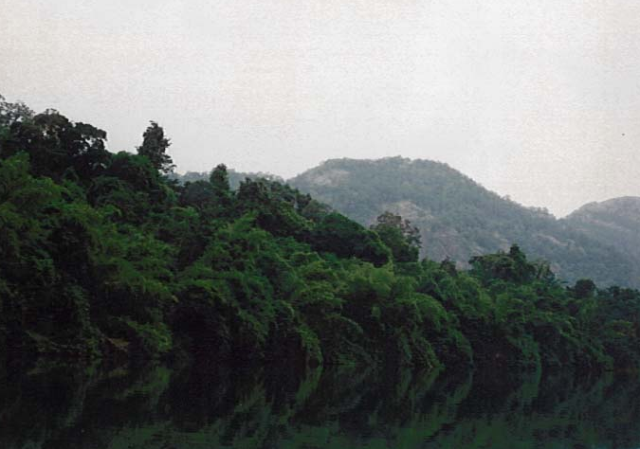
The Forest and Forestry Department: The forests of the Augustayar Valley are thick and provide the home to a wide variety of plants, tree, shrubs, etc. The most important species include terminalia peniculta, terminalia tomentosa, cario harboria, psidium guajava, colophyllum ilatum, arogyapaacha (trichapus zeylanicus), ficus glomerata, phoenix pusilla, michelia champaca, pongamia pinnata, tamarindus indica, madhuca indica and alstonia scholaris.
Figure 2 The Augustayar forest in the Western Ghats of Kerala, where Kani tribal members identified the arogyapaahez plants to a team of scientists from All Indian Coordinated Research Project on Ethnobiology (AICRPE).

Kani Tribals: relationship with biodiversity, culture and forest bureaucracy

The Augustayar Forest is designated as a reserved rain forest. It has several small streams running across the forest and draining into the Neyyar river. In such an area all acts not permitted by the Forest Office of the State Government are prohibited. The Forest Department periodically issues a list of minor forest produce which can be extracted by the tribals living in the forest. It is significant to note that in principle the Forest Department has agreed to include arogyapaacha (trichopus zeylanicus travancoricus) under the minor forest produce list, but formal orders have not been issued (declaration awaited at time of preparation of this case study).

The Kani tribal people live in the forests of the Thiruvananthapuram district of Kerala in south India. Their current population is estimated to be approximately 18,000. Their settlement system is such that a few families live in a cluster interspersed with the forest. The terrain is undulated. Every Kani has a small garden in front of his/her hut and has few plants of rubber and other palms besides some fruits and flowers around their hut. They do limited cultivation of tapioca, banana, millets and cash crops such as pepper, coconut, rubber, arecanut and cashewnut etc., in small plots of land given by the Forest Department. They derive most of their livelihood from crafts, and gathering and selling of various permitted forest produce. It may seem paradoxical that the original inhabitants of this area are dependent on the state for using the natural resources conserved by them for centuries. But the forests were nationalized and despite the recent constitutional amendment making tribal people the custodians of all minor forest species in their areas, the situation at ground level has not improved much. Also the much acclaimed decentralization to panchayat (the village councils) level in Kerala does not seem to have had any major effect on the lives and choices of tribals in the area studied.

The Kanis are reported traditionally to be a nomadic community but most of them are well settled now for a long time. Their economic condition is one of extreme impoverishment. Some of them do not even have a thatched hut. The huts of others were built by the Forest Department and Tribal Department years ago without taking the design and material preferences of the tribals adequately into account.
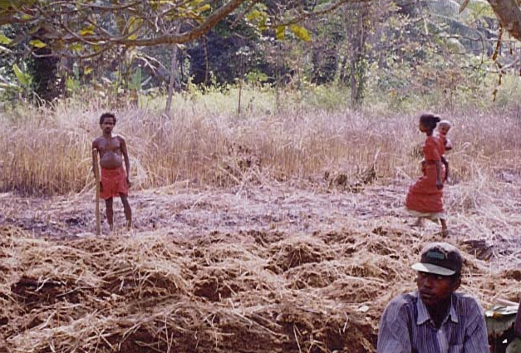
Figure 3 The Kani Tribe, which was traditionally a nomadic community, is now mostly settled under conditions of extreme impoverishment.

Anuradha observes, that traditional structure of the community was that of a highly coordinated unit under the control of a tribal chief, called Muttukani. Traditionally, the Muttukani combined the roles of the law giver, protector and dispenser of justice, physician and priest. However, with time the traditional system of governance among the Kanis has been eroded to a large extent and the role of the tribal chief is only a token one. (Anuradha, 1999). The role of the Forest Department in determining their choices is quite evident even to a casual visitor. There are some settlements on the other side of the Neyyar river on which there is also a Neyyar Dam. One has to go to these settlements by a boat from dam site or by road from the other side. The local social structures have become weaker in proportion to the increase in their dependence on forest department for their survival. The lack of any material goods worth their name in the huts of most Kanis shows that they have been bypassed by the developmental impulses of the last fifty years of the post-independence era. There are some who have better living standards either due to their proximity to outside forces or their social status with in the local communities. The Kani society is quite stratified and the general romanticised view of homogeneous community structure is not applicable.

Tribal physicians among the Kanis are known as ‘Plathi’ – ‘he who is a repository of tribal medical wisdom’. They cure ailments through their traditional healing art which includes administration of various drugs or some magico–religious cures like manthras and rituals. Much of the tribal medicinal knowledge among the Kani is dispensed by the Plathis. Plathis perform various rituals and chants from birth to death with the help of an instrument named kokara. Only they can use this musical instrument. After seven days of the death of a person, they perform the ‘dodhi chant’ to purify the soul of the diseased person. There are more than twenty kinds of chants such as the pini, deeva, twodi, karthikeya chants, etc. In the Quilon district, the Kanis change the Plathi if he is found to be inefficient and the ceremony is known as Nallu Vachu Nokal. Depending upon the number of possible candidates for becoming plathi, they would judge a new person who is qualified to be a priest. Selected people are screened by this ritual to formalize the position of Plathi. Then there is a ceremony called Pallaga yeduppa. They ask the God who should be selected and the selected person has to be approved by God.
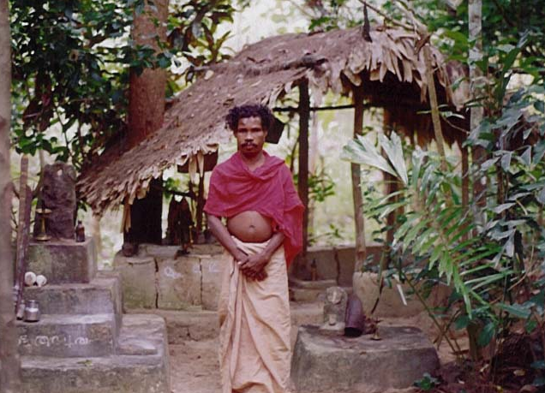
Figure 4 The tribal physicians of the Kani, known as Plathi, are the exclusive holders of the tradtional medicinal knowledge of the tribe.

An existing Plathi trains the new person for about six months. In this chain of formalization of Plathi, the last ritual is Kakar dupa. After the training is over, the new Plathi is allowed to play the Kokara musical instrument. Once he gets this instrument he is considered to be qualified to be a Plathi. For seven weeks, once every week the rituals are practiced for the new Plathi to induct him in his new role. Before giving the musical instrument Kokara to the new Plathi, permission is taken from all those present one by one whether he should give the Kokara to the new person. The Plathis of nearby settlements are also invited on the occasion to offer sanctity. The newly selected Plathi performs the Kadalpok chant on the Kokara musical instrument. The induction process helps generate commitment among the Plathi towards their society. The new Plathi leads the chanting of songs and if he goes wrong, the old Plathi or Plathis from other settlements correct him. By the morning this chant is completed. And this process continues once a week for seven weeks and after it is done the new Plathi becomes properly established. Only after seven weeks he is considered fully recognized. The health tradition of the Kani tribes inhabiting the forests of the Western Ghat region of Kerala is quite rich. The herbal lore of this tribal community of a large number of wild plants found in the flora-rich forests of the Western Ghats holds a lot of potential for the future. Conservation of biodiversity and related knowledge systems thus has to be an important objective of any benefit-sharing system apart from the improvement of local livelihood support systems.

Intellectual Property Rights

The drug Jeevani, on which a national patent application was filed, was developed from the perennial plant Arogyapaacha (trichopus zeylanicus). This plant is a small rhizomatous, perennial herb distributed in Sri Lanka, Southern India and Malaysia. In Sri Lanka it grows in lowland sandy forests near streams. In the Malay Peninsula it is found in low-lying forests. In India it is found at an altitude of around 1000 meters. The sub-species found in India is called trichopus zeylanicus travancoricus. Within India the plant is endemic to the region of the Western Ghats that falls in the Thrivananthapuram district of the State of Kerala and the Tirunelveli district of the State of Tamil Nadu.

Discovery and development of the drug
It was in December 1987 that Dr. Pushpangadan (then with the Regional Research Laboratory in Jammu) stumbled upon the herb while leading a team from the All India Coordinated Research Project on Ethnobiology (AICRPE). During an ethnobotanical expedition to the Western Ghats, Kani tribals who accompanied the team as guides, did not feel tired whereas the scientists were feeling fatigued. They observed that the Kani guides were continously munching black fruits of some plants. They offered a fruit to the exhausted scientists during the trip. “Upon eating the fruits, AICRPE team felt immediately charged and full of energy and vitality (Pushpangadan et al, 1988). The tribals were initially reluctant to reveal the identity of the fruit and pleaded that it was a time-honored tribal secret and a sacred one. After a great deal of persuasion the Kani led the AICRPE team to the arogyapaacha.

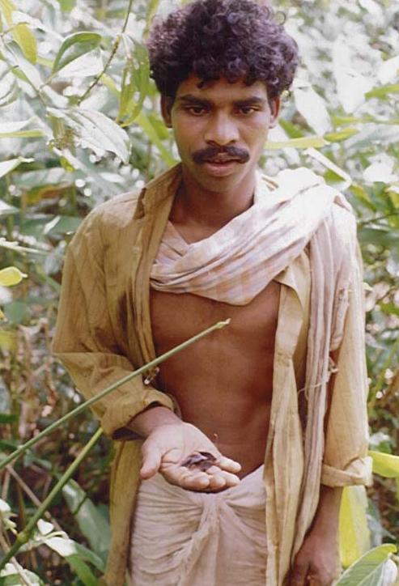
Figure 5 Kani tribal member identifies components of the arogyapaacha plant.
The scientists pursued analysis of arogyapaacha through a variety of chemical and pharmacological tests. It was identified as trichopus zeylanicus. It is likely that only the species found in Agasthyar (Trichopus zeylanicus travancoricus) has the claimed medicinal properties though the plant is found in Malay peninsula and Sri Lanka as well. Detailed scientific investigations including chemical screening to isolate the active principles and pharmacological tests were carried out at the Regional Research Laboratory in Jammu by Dr. Avinash K. Sharma, C. L. Chopra and Pushpangadan..

The analytical approach included both allopathic as well as Ayurvedic tests. The drug was evaluated on the basis of the Ayurvedic dravya guna and rasa shastra. Arogyapaacha was found to belong to the Svathahita (health promoting) group of drugs.

The anti-stress and immuno-stimulating property of the plant were first discovered by the researchers in Dr Pushpangadan’s team. Later they also identified other properties such as tumour control, anti-fatigue, stamina boosting properties, etc. TBGRI conducted clinical trials of “Jeevani”. In India “Jeevani” has been administered orally to 100 human subjects in studies involving either healthy or non-healthy individuals. Studies were focussed to determine the ability to withstand adverse conditions (increased work load exercises), quality of work under stress, athletic performance, increase in mental alertness and work output. Results of this open clinical trials were highly significant and “Jeevani” was found to exert favorable effects in a number of situations.

The research program over the past 12 years has demonstrated that the importance of this medicinal plant alone or in association with other ingredients, as combined in the Jeevani drug, could be higher than that of Ginseng without any steroid being present in it. Its potential was acknowledged in prestigious journals like Nature and magazines like Time.

Recently, the drug has been featured on the cover page of top sports and fitness magazines which claimed that, “having gone through successful clinical trials, Jeevani will soon be made available in the U.S. as an energizer, adaptogen and immune stimulator” (2000). It has also been included in Chinese/Japanese medicine such as “Shosaikoto” with considerable clinical effect. One company in the United States of America has also registered a trademark of “Jeevani” for sale of the same drug in the USA. There is another company which is soliciting plants and/or seeds of arogyapaacha. This drug, based as it is on traditional knowledge of the Kani tribe, seems to have tremendous potential in global markets for natural health care products and sports medicines.
TBGRI isolated five compounds in all from arogyapaacha, but the detailed characterization of four compounds has been delayed due to the lack of adequate technology and equipment. TBGRI has been forced to send these compounds to Copenhagen for characterization, says Dr. Pushpangadan. For the one compound for which characterization was possible at TBGRI without delay, a patent application was filed.

The patent application for the Jeevani Drug
In 1996 TGRI filed a process patent application for a process of manufacture of a herbal sport medicine, based on the compounds isolated from arogyapaacha. The application describes the invention as “a novel, safe herbal sports medicine, having antifatigue, antistress and stamina boosting properties.” The application contains two claims, relating to a process of preparation of a herbal drug from the plant arogyapaacha (trichapus zeylanicus) and three further plants in the form of granules or suspension. The application does not specifically mention the tribal knowledge of arogyapaacha, but it records that “the therapeutic effect of this plant has been established by detailed pharmacological studies. (Pushpangadan et. al. (ed) Glimpses of Indian Ethnopharmacology, pp. 137-145, TBGRI Publication 1995)” and it specifies that “The physical appearance and characters of this plant matches well with the description of ‘Varahi’ described in Susrutha Samitha (Pushpangadan et. al. Ancient Science of Life, 13 – 16, 1988).” With respect to the second plant used in the invention, Wiuthania somnifera or ashwagandha, the application mentions that “Ashwagandha is mentioned as an important drug in the ancient Ayurvedic literature.”

International Cooperation for Research and Value Addition

A collaborative research project entitled “Ethnopharmacology of Indian Medicinal Plants” is carried out between the Tropical Botanic Garden and Research Institute, Trivandrum, and the Department of Medical Chemistry at the Royal Danish School of Pharmacy, Copenhagen, Denmark, sponsored by the Danish International Development Agency (DANIDA). The project is undertaken on a mutual understanding that

- all patents and patent rights developed under this project belong to the Indian partner.
- all scientific publications resulting from this collaboration are published as joint publications between the two institutes.

Under Phase I of the project, two scholars received training in Denmark on screening 70 medicinal plants of pan-tropical Asian distribution in antibacterial, antifungal, antimalarial and anti-hypertensive agents. This would strengthen the capacity of TBGRI in the area of natural product chemistry and additionally during this period the physiochemistry and ethnopharmacology laboratories were equipped with DANIDA assistance.

The second phase of the programme was originally planned to start from July 1997. However, owing to various reasons, especially due to a series of reviews conducted on the progress of Phase I and the review of programmes to be started in Phase II, the scope of the programme was further broadened. DANIDA has now agreed to extend this project for a further period of three years from 1999-2001, with a total financial outlay of 6.6 million DKK. Out of this an amount of 2 million DKK is kept apart for strengthening the spectroscopic and other instrumentation capabilities of TBGRI, which will be received as gift to TBGRI from DANIDA. The remaining amount is utilized for offering doctoral and post-doctoral training to TBGRI staff and mutual visits by other participating scientists from TBGRI and RDSP.

A protocol was designed for clinical trials of an anti-diabetic herbal drug formulated by the Institute. Acetone, alcohol and water extracts of 40 medicinal plants were prepared and studied for their anti-cancer activity. One of the plants showed DNA scission activity and detailed investigation is ongoing.

Mr. Pushpangadan pointed out that patent applications have already been filed for 12 drugs. A sports medicine is being developed and one of the 19 wild species of pepper which was found to have anticancer properties is under valuation. Another 150 species have been identified for valuation.

Similarly, collaboration with Singapore University helped TBGRI scientists to do research using the most advanced ‘through-put-analysis,’ which can screen a thousand plants in one day against the traditional method that takes six months to one year to study one plant.

Tissue Culture:
Before mass production of the compound drug is possible, arogyapoacha has to be cultivated on a large scale. The Institute has started tissue culture for the fast propagation of the plant which is slow in natural multiplication. However, it may not be most necessary to wait for tissue cultured plants for propagation since the tribals have been able to propagate it easily. There are reports that shoot tips of the plant can be used to culture this plant for rapid propagation. The Forest Department has suggested in personal discussions that TBGRI should provide the technology of tissue culture to tribals so that they did not have to collect the plant from the wild. However, the propagation of this plant in moist and shady environment is quite easy and many Kanis tribals have actually already cultivated this plant.

Acquisition of Intellectual Property Rights

It was realised by the researchers led by Dr Pushpangadan that without intellectual property protection they would not be able to generate much revenue by licensing the drug they developed. Since the CBD is an instrument applicable to plant genetic resources and traditional knowledge, they tried to follow various articles of the CBD as faithfully as they could. In 1987, when the discovery was made, scientists took this exploration as a routine ethno-botanical investigation. Early work at RRL Jammu was thus aimed at publishing the findings and in some cases filing patent applications.

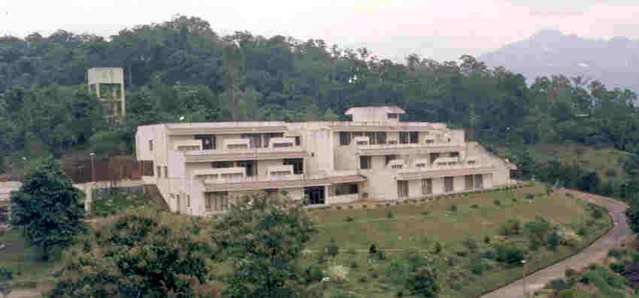
Figure 6 Tropical Botanic Garden and Research Institute (TBGRI), Kerala.

It was only after Dr. Pushpangadan moved to TBGRI that he got fully involved with value addition. The collaboration with DANIDA helped in developing breakthroughs quite fast with all the intellectual property rights remaining with TBGRI. The research team was actually a natural science team and they had no experience of dealing with complex socio-political and socio-economic problems. Dr Pushpangadan had to face lot of opposition and criticism for his attempt to share benefits. If he had done what all the ethnobotanist have been doing all these years, that is record and publish the local knowledge with or without value addition or patent and enjoy the benefits oneself, perhaps he would not have had to face any criticism. It is precisely because he did not take any share out of benefits for himself or his senior colleague Dr. Rajasekharan, and that he achieved extraordinary results in such a short time period through international research, that his motives became suspect to some.

Dr. Pushpangadan faced all of that opposition till he was appointed Director of the National Botanical Research Institute. He continues his interest in the matter and tries to persuade the Forest Department to let this experiment succeed. He also realizes that too much attention on himself and his colleagues by media around the world may have contributed to the indifferent attitude of some of the Forest Department officials. The officials of the Forest Department supported in principle the idea of benefit-sharing, but they had less appreciation for their limited role in design and implementation of benefit-sharing arrangement. They did not seem to mind that patents were obtained, even though KIRTADS was extremely critical of this step.

Two of the patent applications on Jeevani were for
- a process of Preparation of novel immunoenhancing anti-fatigue, anti-stress and hepato-protective herbal drug, (Pushpangadan P., Rajasekhran S. and George V., 1996, Patent application number 959/MAS/96 dated June 4, 1996) and
- a process for the preparation of a Glycolipid fraction from Trichopus zelyanicus possessing adpatogenic activity, (Butani, K. K., Gupta, D. K., Taggi B. S., Anand K. K., Kapil R. S., Pushpangadan P., and Rajsekhran S., 1994, Patent application number 88/Del/94).

In addition there were two more patent applications in which this plant was included. One was for diabetes (957/MAS/96, dated June 4, 1996) and the second a sport medicine (958/MAS/96 dated June 4, 1996).

It is important to note that while the Kani informants had used the plant fruits for vitality and energy, the scientists had made the preparation by using the leaves of the plant. But the fact that the plant was being used for the same purpose for which local people used it underlined the logic of benefit-sharing. After all if the local communities had not conserved the biodiversity, the probability of scientists making any selection at all will be remote or nil. In cases where local communities provide the lead and the use of the biological resource in the TK is identical to the use of the resource claimed in the patent application, the case stands for:
- sharing intellectual property, i.e. shared inventorship,
- shared licensing agreement, and
- common benefit-sharing.

Such a case has not arisen in many situations so far. Several small but multiple institutional changes have to take place if such a philosophy has to be institutionalised.

The Patent (second Amendment) Bill 1999 aims to make many changes in the Indian Patent Act 1970. The definition of chemical process will include “biochemical, biotechnological or microbiological process”, the duration of patent protection will be extended to 20 years as per the minimum standard provided by the TRIPS Agreement, the applicant will have to “disclose the source and geographical origin of the biological material in the specification, when used in an invention” [section 8 (D)], allow product patents (on subjects not otherwise prohibited in the act), reversal of burden of proof, etc.

The most important provisions relevant to the subject of this case study are found in Art. 17:

“(j) that the complete specification does not disclose or wrongly mention the source or geographical origin of biological material used for the invention;
(k) that the invention so far as claimed in any claim of the complete specification is anticipated having regard to the knowledge, oral or otherwise, available within any local or indigenous community in any country”

The above two provisions are two additional reasons on which opposition to any patent application can be pursued. These provisions have not yet been attempted in the patent acts of other countries to the best of the author’s knowledge. It still does not fully ensure that the biological resources and traditional knowledge used by an inventor in a claimed invention have been obtained lawfully and rightfully.

Licensing and the Exercise of Intellectual Property Rights

The governing body of TBGRI authorized the director of TBGRI to transfer the technology for manufacturing Jeevani to interested parties on payment of adequate license fee. Negotiations for the same were conducted by a committee constituted for this purpose headed by the Chairman of the Executive Committee of TBGRI, who is also the Chairman for the State Committee on Science, Technology and Environment, Government of Kerala. The Committee recommended transfer of the right to manufacture Jeevani to the Arya Vaidya Pharmacy (Coimbatore) Ltd. for a period of seven years for a license fee of Rupees Ten Lakhs. TBGRI was to also receive two percent royalty on any future drug sales. This was done as per the guidelines of Council of Scientific and Industrial Research.

TBGRI has stated that it was the best bargain that could be arrived at by their selection committee. They emphasize that the license period is only for the purpose of a promotional venture, and that once the drug is able to establish a market for itself within the license period of 7 years, the license fee could be suitably enhanced and that it could be licensed to another company if that is more beneficial.
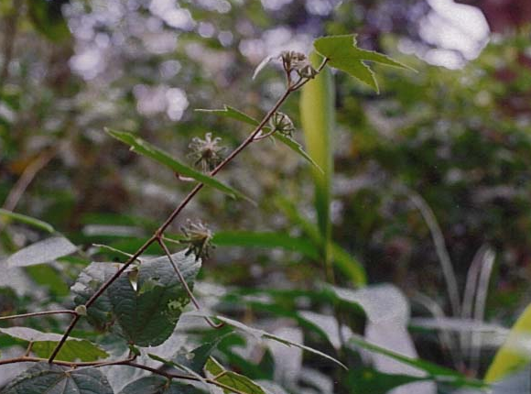
Figure 7 The arogyapaacha plant from which the Jevaani drug was developed and subsequently patented by the Indian research institute TBGRI.

The rules of the Council for Scientific and Industrial Research (CSIR) are specific that technology can be transferred to other parties, including private companies for a trial run, free of cost.

TBGRI has also entered into technology transfer agreements with the Madras-based Velvette International Pharma Products for the production of a herbal health care kit consisting of 14 drugs. The herbal preparations were developed according to WHO standards at the Ethnomedicine Division of the Institute. The kit contains 14 scientifically validated drugs in granule, tablet, powder, capsule, ointment and oil forms. It is designed to tackle all the common ailments afflicting a person including fever, headache, cold, cuts and wounds, diarrhea, dysentry, inflammation and burns.

The first tranche of Rupees 5 lakh and royalties of Rupees 19,000 of the benefit-sharing formula were deposited in the account of Kani Samudaya Kshema Trust at Kuttichal Union Bank. The first meeting of the Trust after the transfer was held at the Kallar Mattammodhu Kani tribal settlement on March 19, 1999. In the meeting it was decided to grant Rupees 50,000 as special incentive to Mallan Kani (Rupees 20,000), Kuthy Mathan Kani (Rupees 20,000) and Eachen Kani (Rupees 10,000) who passed on the information to the scientists.

The special secretary of the SC/ST Development at state level, Mr. Subbiah feels that the Trust should float a factory and begin production after the agreement with Arya Vaidya Pharmacy expires. This is to ensure that the tribal people retain the control of production and marketing. However, scientists at TBGRI are wary of the idea. They feel that tribals could gain more by licensing the rights to private producers though they are not averse to the idea of experimentation. They realise the need for local value addition so that higher share of value chain remains in local area.

A team of experts from a Japanese pharmaceutical firm visited the capital city and initiated negotiations with the government to purchase the DNA rights of the plants. They reportedly offered Rupees 10 crores for outright purchase. The government is understood to have rejected the offer. The fears about the possible patenting of arogyapaacha plant by foreign entities are quite strong in the mind of local officials and leaders. In addition, they want to ensure that their right to use this plant should never be compromised. This would require that a patent would be granted in India for the plant and it is not possible under Indian Patent Act 1970 as amended.

Benefit-sharing

Establishment of the Trust

In November 1997 with the assistance of TBGRI a trust was registered, named the Kerala Kani Samudaya Kshema Trust. The Trust has been registered with nine members, all of whom are Kani tribals. The president and vice-president of the Trust are the two Kanis who imparted the traditional knowledge to TBGRI regarding arogyapoacha. The decision to form the Trust was taken in a local meeting of around 40 Kanis. The Trust deed states the objectives of the Trust to be:

- welfare and development activities for Kanis in Kerala,
- preparation of a biodiversity register to document the knowledge base of the Kanis,
- evolving and supporting methods to promote sustainable use and conservation of biological resources.

The aim of the Trust is to have all adult Kanis in Kerala as its members. Kanis in the vithura and permigamala panchayat areas are opposed to this Trust. Members of the Trust are of the view that once the Trust becomes functional they would be able to organize the Kanis better. Awareness about the Trust is very low and even those who are aware, are often sceptical about its effectiveness. There has been some criticism of the Trust and the mode of sharing benefits.
Figure 8 Kani tribal memebers should benefit from the Kerala Kani Samudaya Kshema Trust, which was established to share royalties from the patent on the Jeevaani drug.

John and Sindhu (1998) highlighted the grievance of several Kanis about their lack of awareness about the Trust, new medicine developed, and the future program of development. The Director of KIRTADS complained that intellctual property rights were not being sought by local tribals and instead rights were being granted to private entities. There was a suggestion about enacting new laws which would grant intellectual property protection to Indigenous peoples like the Kanis instead of only to the formal scientists or outsiders. Suman Sahay, Coordinator, Gene Campaign, felt that TBGRI, by taking out a patent for Jeevani, has “effectively challenged the principle of the Common Heritage of Mankind, which considers all genetic resources the property of everybody, with no particular ownership.” Many of these observers have overlooked that the patent applications by TBGRI were only for the process of making drugs, because Indian patent law did not permit product patents until now. Thus nobody’s right was affected adversely by the patent applications in any real sense, because what was in the public domain will remain so before and after such patents have been granted. The formulation that TBGRI had developed was sought to be protected. But as is well known, the Indian patent office takes a long time to issue patents. Applications made in 1996 are yet to be processed.

Earlier Dr. Pushpangadan had proposed to route the funds through the Tribal Department of State Government. He contacted the author of the present case study, Prof. Gupta, and was persuaded to set up a Trust Fund rather than route the funds through a State Government body. This was supposed to provide greater flexibility and control to the Kanis. It is true that the process of trust formation could have been more participative within the settlements from which Kanis were included. TBGRI did take the help of some regional NGOs in creating trust and generating awareness, but it was not adequate. However, the fact that Kanis could dare to protest against Forest Department when they were not being given the right of collecting leaves of arogyapaacha, shows that capacity was built among them to participate actively and consciously in the decision making processes which affect their TK.

The Trust is currently working out a scheme to utilize the funds. A tentative project is to set up a Telephone booth which will be the first one in the Kottor area bordering the forest belt. An insurance scheme for pregnant women and another to cover accidental deaths is also being worked out.

Sustainable Extraction

During the harvest of leaves, some people uprooted the whole plant from their gardens and some others took the wild herb from the forest. This alerted the Forest Department against possible large scale “smuggling” of the herb. Scientists at TBGRI also feel that this should not be done since sustainable collection of the leaves of the plant is possible. They emphasize that only the leaves of the plant are required for the production of Jeevani. In a widely reported operation in 1996, 10,500 plants of arogyapaacha were confiscated, which had been collected for a private nursery at the Vithura village in Thuruvananthapuram.

The Arya Vaidya Pharmacy is disappointed that despite there being a good market for the Jeevani drug, there is no raw material to manufacture it. AVP had written to the Kerala Forest Department and the Tribal Welfare Department proposing a plan for the cultivation of arogyapaacha, whereby it would pay the Kanis an initial seed money for the cultivation of the plant and enter into a buy-back arrangement with the Kanis to buy the leaves harvested from the cultivated plants. It is prepared to buy five tonnes of leaves a month. However, the Forest Department rejected AVP’s proposal explaining that the collection could not be permitted because it concerned an endemic plant. AVP is willing to cooperate with the State Government in arriving at a mutually beneficial and sustainable mechanism for harvesting the plant.
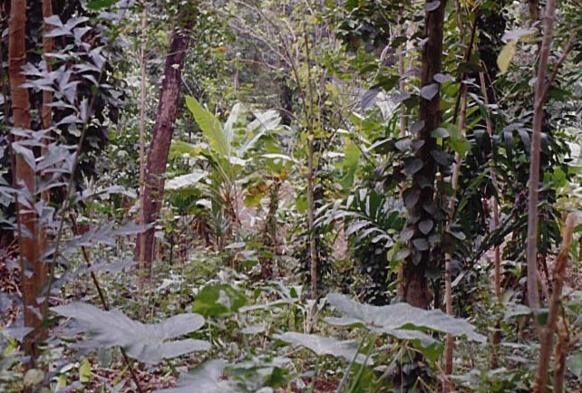
Figure 9 Sustainable extraction of the arogyapaacha plant in the Augustayar forest has been of concern to the Forest Department.

The Forest Department has been quite concerned about sustainable extraction and thus had not allowed this plant to be commercially exploited so far. Unless they include this plant in the list of minor forest produce, it will not be allowed to be sold.

Discussions with the Forest Department in November, 1999, suggested that TBGRI should agree that any drug which it develops from forest-based plants should be licensed for commercial use only under three conditions.

- all the four parties, i.e., TBGRI, the Forestry Department, the local community institutions, and the licensees should be involved in the discussion.
- A sustainable extraction plan should be submitted by the licensee to ensure that commercial utilization does not pose any threat to the ecosystem or long term sustainability of the species.
- Research programmes on such plants should be reviewed by TBGRI and the Forest Department from time to time so that if any endemic, endangered plant provides a lead for a valuable medicine then, unless technologies are developed for ex-situ cultivation through tissue culture, such a technology will not be commercialized and licensed lest the plant becomes extinct.

Lessons Learned

The need for multi-stakeholder frameworks for discussing the scope of access, value addition and benefit-sharing was brought to light by this case study. If the Forest Department has jurisdiction over a territory, then the Department must be included in the stakeholder discussions while establishing benefit-sharing mechanisms.

Further, the rights of informants and that of the community need to be distinguished in the benefit-sharing arrangements. The informants were the first to receive payment from the amount deposited in the community trust. Actually they should have been paid from the resources that scientists and research institution (in this case, TBGRI) received. By not doing so, an avoidable impression was created among the Kani tribals that the trust was supposed to benefit only a few community members. The real intention of the scientists was to help the community to manage resources through their own volition and institutions. To that extent, this model of a Trust Fund was more democratic and accountable to the local community than was the Trust Fund developed in the Nigerian BDCP case. Comparison between the two cases shows that one needs to experiment with different models in different cultural, ecological and institutional contexts.

It is important to note that the Trust Fund came into existence only because patent applications were filed for the value-added processes developed from local knowledge and licensed to a commercial entrepreneur. The fact that scientists did not claim any share from the license fee goes to prove that their values and motivations, as reflected in the benefit-sharing arrangements, were focused on equity and the fair sharing of benefits.

- The patent applications filed on drugs based on arogyaapacha were all national process patent applications, none had been granted, and yet licensing of the technology had already yielded a very good amount, fifty percent of which was shared with the community. This is an important indicator of the potential which the effective use of intellectual property rights might have to generate benefits which can be shared with the communities. As this case illustrates, the use of intellectual property rights can in some cases help to generate benefits, even before exclusive rights over the TK-based invention are granted.

- The scope of benefits to be shared could have been much wider if:
- international patent applications had been filed under the Patent Cooperation Treaty administered by WIPO, to protect the formulation in countries other than India;
- product patents were available in India for pharmaceutical products, not only process patents, and
- trademarks had been registered to protect the distinctive signs distinguishing this product from those of other undertakings.

At the same time, these intellectual property rights would not have restricted the rights of local communities.

- The case highlights the possibility of third party Trademark protection as done by NutriScience Innovations, LLC, USA which owns Jeevani Trademark in the United States of America. This in turn would have generated a much higher share of funds to be shared with the Kani tribe and also to fund future research. The exposure this drug is getting internationally demonstrates the potential that lies ahead.

- The case illustrates that while intellectual property rights play a crucial role in generating benefits from biological resources and traditional knowledge, which can become subject to benefit-sharing, their role should be balanced with the conservation objective:

The increase in demand could have led to excessive extraction of the biological resource,
- if adequate awareness was not raised among all stakeholders,
- if local institutions of sustainable extraction were not supported or created, and
- property rights of individual experts and communities in the biodiversity and associated knowledge were not negotiated and defined at local level legitimised through state and national policy instruments.

Such a possibility did arise in the early stages of the case when many people started buying this plant at the rate of Rs 100 per kilogram. The Forest department had to impose restrictions when they confiscated illegally collected leaves and whole plants. The offer of the Arya Vaidya Pharmacy of giving a buy back guarantee to the Kanis along with the technology to cultivate and extract leaves in a sustainable manner was one answer to this problem.

The effective protection of intellectual property is a necessary condition for generating benefits, which will be subject to benefit-sharing, but it is not a sufficient condition. Several additional measures are needed to supplement the role of intellectual property rights in benefit-sharing over biological resources and traditional knowledge.

- The objective of the Kani Samudaya Kshema Trust to establish a biodiversity register to document the knowledge base of the Kanis must be pursued with the intellectual property implications of such a register in mind. Intellectual property questions to be resolved for the creation of such a register include who operates the register, who provides access to its contents to which parties on which terms, who conducts documentation of the knowledge, who has the right to authorize documentation on behalf of the tribes, which knowledge elements will be documented in which format, how to deal with local language documentation in relation to national and international use of the register, etc.

- The degree of involvement of various tribal settlements and groups could have been increased. The rights of informants vis-à-vis the communities requires more discussion among the communities themselves.

- The non-material contribution of benefits by way of empowerment of local communities deserves to be noted, but several more such benefits could have been considered. For instance health check-ups for the local communities were urgently needed given the very poor condition of many women, children and also some male adults.

- The role of the Plathis as an informal association of healers which hold rights to the use of certain traditional medicinal knowledge was not recognized by the benefit-sharing arrangements in this case. Building on existing and accepted institutions of traditional knowledge holders can be an important tool to structure their participation and ensure the acceptance of the communities for benefit-sharing arrangements.

- The Forest Department had not permitted the cultivation and collection of the arogyaapacha plant. This was so in spite of the fact that the plant could be easily cultivated and many tribals had actually done so. Discussions with the tribals on the subject elicited a sympathetic response. If the Forest Department had been involved from the beginning in this value chain, perhaps their attitude might have been different.

- The tribal informants were not named as co-inventors in the patent application. This option should be explored as a practical intellectual property-based benefit-sharing mechanism between TK holders and the formal research and development institutions.

Click here to see the annexure 3.3.1

Article 16(g) of International Convention on Combating Desertification also echoes similar concerns for dry region when it provides for exchange of information on local and traditional knowledge, “ensuring adequate protection for it and providing adequate benefit from it, to the local population concerned”. See, United Nations Convention to Combat Desertification (1996).
The assumption is, that flow of material benefits to local conservators – communities or individuals - may impair their values and weaken their conservation ethic. Obviously, it is also assumed that our values can remain intact despite the accumulation of wealth.
Anuradha, R V, 1998, Sharing With Kanis: A case study from Kerala, India, New Delhi: Kalpvriksha Mimeo
Conforming to WHO standards, 1991.
Salim Saslin. “Challenging Ginseng: Arogyappacha, The health food of the 21st century,” The Week. August 29, 1993
Report of the All India Coordinated Project on Ethnobiology – Undated.
Anuradha, R. V. “Sharing With Kanis: A case study from Kerala.” New Delhi: Kalpvriksha Mimeo, 1998, and personal field work.
Dr. P. Pushpangadan was the Chief Coordinator of AICRPE at that time.
Pushpangadan, P., Rajasekhran S., Ratheesh Kumar P. K., Jawahar C. R., Velayudhan Nair V., Lakshmi N., and Sarad Amma L. “Arogyapacha (Trichopus Zeylanicus). The Ginseng of Kani Tribes of Agasthyar Hills (Kerala) for Evergreen Health and Vitality.” Ancient Sciences of Life 7 1988: 13-16.
Pushpangadan, P., Rajasekaran S., Latha P. G. , Evans, D. A. and Valsa Raj, R. “Further Studies on the phramacology of Trichopus zeylanicus.” , Ancient Science of Life, Vol. 14(3) 1995: 127-135.
Dr. P. Pushpangadan, Personal Communication, 1999.
Subramoniam, A., Madhavachandran, V., Rajasekharan, S., Pushpangadan, P. pp“Aphrodisiac property of Trichopus zeylanicus extract in male mice.” Journal Of Ethnopharmacology, Vol. 57(1) June 1997: 21-27. Subramoniam, A., Evans, D.A., Valsaraj, R., Rajasekharan, S., Pushpangadan, P. “Inhibition of antigen-induced degranulation of sensitized mast cells by Trichopus zeylanicus in mice and rats.” Journal Of Ethnopharmacology, Vol. 68(1-3) December 15, 1999: 137 - 143.
Jayaraman, K. S.. “Indian Ginseng brings royalties for tribe.”, Nature 381 May 16, 1996.
Meenakshi Ganguli. “Descendants of "God's Physician" Share Their Secrets,.” Time. Nov 9, 1998. and r Reprinted in Japanese language version, No 38, February 1999.
"Jeevani: The Anti-Stress/Pro-Energy Botanical Complex", Natural Bodybuilding and Fitness. New York, February, 2000.
Amagaya, S., and Ogihara, Y. J.ournal of Ethnopharmacology. 28 1990: 357; and also see Hiai, S.: In: Adv. Chin. Med. Mat. Res. ( year unknown) cited in Wagner, Hildebert. “Drugs with Adaptogenic Effects for strengthening the powers of resistance,” 1996, available at <http://www.healthy.net/othersites/hobbs/index.htm>;, or <hwinfo@healthy.net>
See, <http://www.nutriscienceusa.com/productinfo22.htm>, sales staff, personal communication, April 24, 2000.
See, <http://florawww.eeb.uconn.edu/invmenus/wishlist.html>.
Krishnan P.N., Sudha C.G., and Seeni, S. “Rapid propagation through shoot tip culture of Trichopus zeylanicus Gaertn., a rare ethnomedicinal plant.” Plant-Cell-Reports 14(11) 1995: P 708.AB 50140708.299.
In the case of SRISTI and GIAN ( Gujarat Grassroots Innovation Augmentation Network), the patent applicationss have been filed only in the name of the local innovators. Though the inventors have assigned the patent to SRISTI to safeguard their interest, the entire licensing fes have been paid to the innovator with GIAN or SRISTI not keeping any share or brokerage. This decision was taken despite the fact that they added value and SRISTI has provided initial venture risk capital also. Some body has to pay for reducing the transaction costs ( both ex ante as well as ex poste) of linking what linking innovations, investment and enterprise (which has been called the Golden Triangle for Rewarding Creativity; Gupta, 1996, 1998, SRISTI and GIAN 1997). Thus it is desirable that various mediating institutions charge for their services or contribution in a reasonable manner so that they do not remain dependent on out side stakeholders or funders or even on the state. Whether the benefits should have been shared in fifty-fifty ratio as was done in the present case by TBGRI, or any other ration will depend upon the case specific situationscircumstances of the case. Past experiences suggest that benefits should not be shared only in the form of money or other material contributions but should also include other inputs such as non-monetary contributions through capacity building, awareness creation, education, removal of informational asymmetries, sharing of research findings, acknowledgement of knowledge providers on product packages as was suggested in Nigerian case.
John J. and Sindhu Menon. “Kerala Tribe Accuses Indian Biologists Of Stealing Knowledge.” PANOS Biopiracy London, August 4, 1998.
Director, TBGRI iIn personal discussions the Director of TBGRI appreciated that both the senior scientists involved in development of Jeevani did not take any share from institutional royalties, in ordery to set an example and prove that they had only foremost the public interest in mind their heart while doing all that they didmaking the benefit-sharing arrangements. But he also felt that several other scientists would rather wish that they got some share out of license fees and royaltiesy. The norms in thsis regard were are yet to be developed.
NutriScience Innovations LLC, personal communication by email, April 24, 2000 on enquiry a s to whether they owned the “Jeevani” trade mark or had taken it on license from AVP Ltd.

