Sharing Benefits with the Conservators of Diversity

M any factors, including socio-economic and cultural changes, influence farmers' decision to grow local varieties. Given these pressures, it is useful to understand how farmers' innovation provided hope to conserve and augment agricultural biodiversity by improving productivity and/or reducing costs through other complementary innovations.
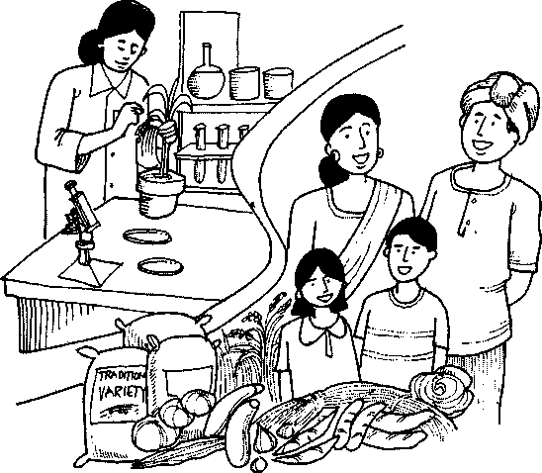
The debate on agricultural biodiversity conservation is
generally characterized by three stands:
• The entire diversity should be a public domain with open access, which is basically how the green revolution became possible. For similar growth production to be possible in the future, agricultural biodiversity conservation is essentially through ex situ genebanks.
Conservation and Sustainable Use of Agricultural Biodiversity
ASourcebook

- Conventional breeding approaches have not produced
significant increases compared to many crops decades
ago. This has created the need for biotechnology to
augment the farmers' choices through generation of
new varieties. Private and public sector investments
in biotechnology would require adequate returns,
hence, legal support through the enactment of a
stronger intellectual property rights (IPR) regime is
necessary.
- Agricultural biodiversity conservation in areas where
it already abounds (i.e., drought-prone, flood-prone,
forests, marginal rainfed regions, etc.) may best be
achieved by in situ conservation with some extent of
participatory breeding (much of which is restricted to
providing farmers some choice to select from
advanced lines bred by breeders).
Major Threats to Agricultural Biodiversity
In order to identify the incentives needed to encourage farmer-breeders to conserve and develop new varieties themselves through their own selection and crossing processes, with or without outside help, it is necessary to know what are the major threats to agricultural biodiversity: • Decline in agricultural biodiversity in the last three decades is attributed to the diffusion of high yielding varieties (HYVs) and hybrids developed by public sector research institutions. The private sector - at least in the Asian region - had a negligible role in this. The reasons are obvious. Seed replacement ratios varied in most crops from 5% - 30% and the share of private seed companies in such seed market has been small. Fear of losing agricultural biodiversity with the entry/expansion of the private sector is possible, though it need not necessarily follow. Some private companies, i.e., a French seed industry offers an interesting variant in the European context where farmer-breeder cooperatives have successfully competed with large multi-national corporations in many crops.
Sharing Benefits with the Conservators of Diversity

• The consumer
preference for
local varieties (e.g.,
millets, sorghum,
etc.) has gone
down due to a
kind of
'sanskritization¹ effect, i.e., lower income classes (which consume these grains) tend to emulate the behavior of higher
income classes (which consume rice/wheat) to aspire for better social status.
- Cheap, subsidized grains like rice and wheat
distributed through the public distribution system and
through the food-for-work program further depressed
the demand for local grains and varieties.
- Lack of price and procurement support for local
varieties reduces incentives to grow them
commercially.
- The allocation of better land and plots for HYVs,
which responded to external inputs, left only the
marginal land and plots for local varieties. Where
environmental risks affect the productivity of these
crops much more, farmers grow these crops in niches
where better alternatives do not exist.
The Honey Bee Network documented innovations based on outstanding traditional knowledge primarily from India (see other paper on Farmers as Plant Breeders: Three Cases from India). Many of these innovations are extremely simple and can improve efficiency of farm workers, women, small farmers, and artisans among others.

610
Conservation and Sustainable Use ot Agricultural Biodiversity
ASourcebook

Policy Measures to Augment Agricultural Biodiversity and Benefit Sharing with Conservators to Diversity
Conserving agricultural biodiversity poses many challenges, many of which deal with incentives that local communities need to have for growing local varieties. These incentives are summarized below.
Policy Incentives
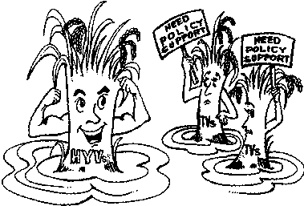
- Increase demand for local landraces through
development of niche markets.
- Compensate farmers in each region for growing low-
return landraces based on the difference in
productivity and price of HYVs and local landraces.
- Support local farmer-breeders and communities in
participatory breeding, with or without involvement
of scientists, to improve landraces and make them
viable in the market place through increased
productivity.
- Link agricultural
biodiversity
conservation with
the development
of organic
agriculture and
provide
institutional
support for
certification of
output,
development of
marketing channels, generation of
consumer demand and postharvest processing and
branding.
• Provide non-chemical inputs such as herbal
pesticides, beneficial insects, technologies for
enriching farm yard manure, etc., to economize
cultivation of local landraces.
Sharing Renefibwiththe Conservators ot Diversity
Prioritize policy measures aimed at procurement of local landraces while designing food security programs and buffer stock.
Share benefits with local agricultural biodiversity conservators whenever local landraces are used for breeding varieties by the public or private sector inside or outside the country (provision in the national plant variety acts for Gene Fund as attempted in the Indian Plant Variety and Farmers' Rights Bill).

Non Material Incentives
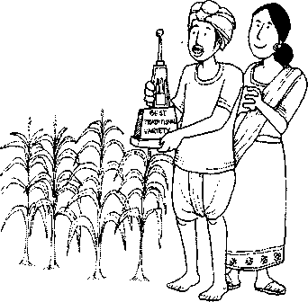
- Provide awards and honor for conserving rare or
endangered variety to sustain agricultural biodiversity.
- Include lessons and references to the contribution of
specific communities to the agricultural biodiversity
conservation in school curriculum.
- Acknowledge the indigenous knowledge provided by
farmer-conservators in the passport data sheets of
germplasm in genebanks, which, unfortunately, is not
being practicea anywhere yet.
- Develop an international registration system (such as
INSTAR proposed by SRISTI, in 1993) to protect
intellectual property of communities and individual
agricultural biodiversity conservators.
- Generate data required for plant variety protection, as
farmers on their own, cannot generate all
formalities involved in the matter;
non-government organizations
(NGOs) supporting local conservators in this matter should also be strengthened.
• Establish a risk fund
to encourage local
communities and
innovators to take up
test marketing, value
addition and seek
outside help.

1612
Conservation and Sustainable Use of Agricultural Biodiversity
ASarcebook

Conservation through Competitions:
Organizing Biodiversity Contests to Close the Gap
The Society for Research and Initiatives for Sustainable Technologies and Institutions (SRISTI) has organized biodiversity contests among children to scout 'little geniuses'. Several children such as Mahadev Sodha, age less than 11, in Banaskantha district in India knows 309 plants; and Ankita; a girl of the same age knows as many as 165 plants. How many kids have this kind of knowhow? Will they grow to become naturalists or guardians of diversity or just become landless laborers?

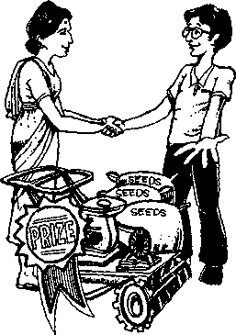
Incidentally, women-headed or managed households are very numerous in rainfed, drought-prone regions and in mountainous and forest regions. It has been argued that if these regions of high biodiversity are also regions of high poverty, then diversity cannot be conserved because people will continue to look for other means to earn and neglect traditional practices including growing traditional varieties. Various kinds of incentives will have to be developed which may include material and non-material rewards for individuals and for communities or groups.
Biodiversity contests help transfer
knowledge across generations (and thus closing the gap) in much
lesser time and with greater efficiency.
Providing policy support and incentives to millions of knowledge rich, but economically poor people to disclose their innovations can help explore the possibility of an investor or entrepreneur from one part of the world to work with them and set up a productive enterprise. Thus, grassroots creativity can harness global capital and entrepreneurial support for decentralized development.

Contributed by.
Anil K. Gupta
(Email: anilg@iimahd.ernet .in)
Sourcebook produced by CIP-UPWARD, in partnership with Gil GmbH, IDRC of Canada, IPGRI and SEARICE.

Sharing Benefits with the Conservators of Diversity 6 ] 31

