Outlook Special Issue on Science & Technology, July 18, 2005, p. 55

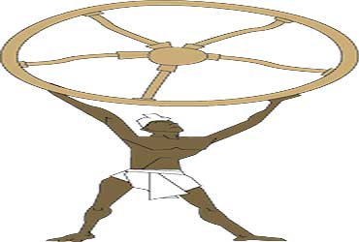
Jayachandran

OPINION
Potter's Wheel
Rural India creates more than just poverty. A wealth of ideas awaits.
ANIL K. GUPTA
In the wake of globalisation, why should one pay attention to grassroot innovations? Does it matter if someone in a rural area has designed a mechanical coconut husker that simplifies the task? A grassroot innovator from Madurai has created a machine to peel garlic without damaging its quality. And entrepreneurs from Pakistan want to buy it. Another one from Singapore read about an arecanut peeler on the National Innovation Foundation website and placed an order.
More than 50,000 innovations and traditional knowledge scouted across 300 districts of India by the NIF, largely with Honey Bee Network's help, is not a mean achievement.
  The poor are not just the bottom of the pyramid or product consumers, they can provide a lot of knowledge.
  For each innovation or instance of traditional knowledge documented, there are thousands waiting to be tapped. The Honey Bee Network's story is of making India innovative and a global leader in sustainable technologies. The poor are not just the "bottom of the pyramid" or consumers of products, they can provide knowledge and innovation.

How do we link knowledge-rich, economically poor people with modern institutions of science and technology, design, manufacturing and marketing to scale up their innovations? The Department of Science and Technology set up the NIF in March 2000 as a communication channel between creative voices at the grassroots and policymakers, entrepreneurs, investors and stakeholders in the knowledge and innovation chain. But we need more volunteers in the public and private sectors, voluntary organisations, farmers' and labourers' organisations to join hands. It would be appropriate if the 11th Five Year Plan takes innovations and entrepreneurship as the national planning system's focus.
The Honey Bee Network was set up 16 years ago to deal with the lack of accountability towards the creative knowledge holders. Can we ensure that people whose knowledge we document won't complain as we have not yet created a legal framework to protect their knowledge rights? In India, there are 4,00,000 technology students. If even one per cent of their projects were to add to local knowledge, 4,000 problems will get solved or at least analysed. Why don't government institutions address this issue?
We set up the Society for Research and Initiatives for Sustainable Technologies and Institutions (SRISTI) in 1993 to provide an institutional back-up to the Honey Bee Network. iim-a provided support for policy advocacy and institution building. In 1997, the first Grassroots Innovation Augmentation Network (GIAN) was set up to link innovations and investment. GIAN also became a conduit to mobilise risk capital for small innovations and began the first micro venture innovation fund in India. In October 2003, SIDBI set up a Rs 5 crore fund at NIF to support innovations.
The incubation of these technologies through product development on a large scale is still a challenge. NIF has helped set up a network of GIAN centres, but we need more GIANs if support has to be provided to thousands of knowledge holders and grassroot innovators. Unless we realise that keeping the poor engaged in low value-adding activity will only perpetuate their poverty, a market for innovations will not emerge. The fact that thousands of crores spent on rural and agriculture development plans do not incorporate creative solutions developed by farmers or artisans proves there is a long distance to be covered. Today, the grassroot innovators are charged the same testing fee for their innovations as other corporations. This needs to change and scientific labs must cross-subsidise.
The MoU between CSIR and NIF signed last year and the discussions with ICAR have given hope that the linkages between formal and informal knowledge systems will become stronger. We have begun several initiatives to deepen our understanding of the dynamics of making India innovative. We are setting up AASTIIK (Academy for Augmenting Sustainable Technological Inventions, Innovations and Traditional Knowledge) to encourage people from formal and informal sectors to analyse the heuristic means used by innovators and understand how social capital can be enhanced around these innovations.
Having walked for 2,600 kms in the last seven and a half years, I can say there is a tremendous vibrance at the grassroot level expressed through creative solutions which needs to be recognised, respected and rewarded. President Dr A.P.J. Abdul Kalam deserves our gratitude for honouring these innovators in the last two award functions and boosting the morale of a secular, socially-committed network, who are developing solutions to persistent old problems.
Democratisation of innovations and reversing the value chain from consumer to producer are two key features of people-driven innovations. Increasing demand for grassroots innovations from companies in the US, Singapore, Pakistan, Malaysia, Brazil and many other countries demonstrates the potential grassroots innovations have to influence globalisation.

(The author is Professor of Entrepreneurship, Indian Institute of Management, Ahmedabad, and founder of the Honey Bee Network.)

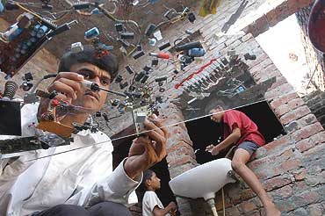
Narendra Bisht

RURAL INNOVATORS
Gram By Microgram
Across rural India, Indians have turned serious innovators. These are the stories of individuals, practitioners of rustic science that is compelling, practical and applicable. The ideas are aplenty—amphibious cycles, pedal washing machines, convertible tractors. But many of them will need more than just recognition for their survival.

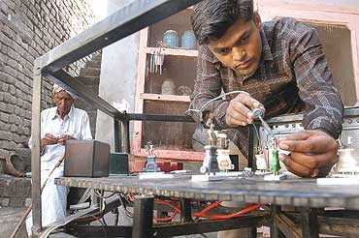

RURAL INNOVATORS
Balram Singh Saini & Prem Singh
Pasiala, Haryana
SAIKAT DATTA
As a billion ideas whiz past through his neurons, Prem Singh Saini is hard at work trying to reshape the future. Across his street two buffaloes sit languidly and stare, almost in wonder at the next great idea that is likely to pop into Saini’s head.

With over a hundred innovations to his credit, including over 30 which have found acceptance from the National Innovation Foundation, one would expect Saini to be crackling with energy. Instead, a man on the edge of frustration sits in his house looking at a pile of letters that are vague in encouragement and firm on denial.
In Pasiala village near Ambala, the Saini brothers are well known. Younger brother Balram, also an innovator, switched to politics after a similar disillusionment with the Indian scientific community’s bureaucratic alleys. Two years ago, Prem Singh was rubbing shoulders with the likes of President A.P.J. Abdul Kalam and CSIR director general R.A. Mashelkar on the Mughal Garden lawns. Prem Singh’s latest innovation—a water pump that is operated through a GSM mobile phone—was interesting enough to merit an invitation. "It’s quite simple," says Prem, "and you can use it to switch it on and then off by simply placing a call."
A call from the mobile phone switches the pump on. A few hours later, the owner can place another call and after an appropriate number of rings, the pump is switched off. "Even a call charge will not be levied," says Prem, cautioning that, "of course you have to remember whether you are switching it on or off." The pump will not work if there is a call from a wrong number.
Since then, Prem Singh and his ideas have made several trips to Delhi, including a trip to the PMO. He was asked to meet a joint secretary in the PMO for further consultation. "He told me that if they helped me, then they would have to help thousands of others. That ended the meeting and I came back to Pasiala," says Prem. His other innovation, which he claims can end train accidents, also evinced little interest in the railway ministry. "Earlier I was asked to meet several officials from the railway safety board but no one had the time. I finally gave up."
Prem Singh came to Delhi when he was asked to appear at an army technology seminar. Once again, officials only had advice and little else. "Army chief Gen J.J. Singh’s only advice to me was not share my technology with terrorists. I haven’t heard from the army HQ." Even a letter from CSIR’s R.A. Mashelkar in February 2003 promising help has now been buried in his pile of letters. "I never heard from them ever since."
His younger brother, who also doubles as the sarpanch, holds out his home-made mechanism to burst fire-crackers through a remote-controlled device. "Two years ago a nephew burnt his hands. Since then I have been working on this idea." A few months ago, Balram was approached by a Gujarat-based trader to turn his idea into a business venture. With seed money of Rs 25,000 in his kitty, Balram is now tinkering around in his makeshift workshop to build a prototype. "If this works, we will market it." From saving fuel to safety devices, running cars on auto-pilot to making robots that can man the borders, water pumps that switch on when the water is released and switch off once the tank is full—the Saini brothers have ideas a dime-a-dozen. But in little-known Pasiala, as the farmers get ready to rain-feed their thirsty crops, there’s barely any recognition of these home-grown Edisons.

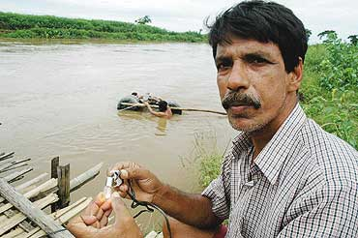

RURAL INNOVATORS
Nripen Kalita
Jiakur, Assam
WASBIR HUSSAIN
Nripen Kalita began his career repairing television sets and other electronic items.Today, he is known as the inventor of the zero-head water turbine, a low-cost equipment that can generate power to light up rural homes and run pumps to irrigate farmers’ lands. "Every monsoon, as the water level in the rivers rose, I used to think of ways to utilise hydro power in a cost-effective manner," says Kalita. In 1998, he developed a water turbine using a bamboo platform to keep the machinery afloat. But he soon realised that using bamboo was not practical.
He then developed an advanced model and has transferred the technology to a local entrepreneur. In a live demonstration, Kalita gets his equipment—an iron wheel with rotor blades, some pulleys, an alternator and a lot of wires—lowered into the river water, with two hollow plastic drums attached to the device to keep it afloat. The rotor blades start moving, lighting up a bulb and turning on a pedestal fan. Kalita has applied for a patent for his innovation but there are bigger dreams too: "I have developed a spinning device that runs on both alternate and direct current. This will be useful for the weavers in Assam." He also wants to create a ‘solar gasifier’ that can use the sun’s energy to generate gas for cooking.

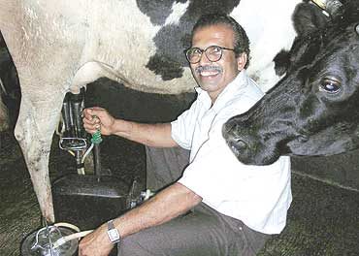

RURAL INNOVATORS
Raghava Gowda
Murulya, Karnataka
SUGATA SRINIVASARAJU

Raghava Gowda could have continued to be a 52-year-old schoolteacher in Dakshin Kannada’s Murulya village. But instead he is the inventor of Milk Master, a cow milking machine now being used by over 300 dairy farmers across India.
It began when the cow Gowda once owned, one that gave him plenty of milk, started having problems. Those days, Gowda, a busy teacher, couldn’t find time to keep her clean, and she developed a chronic udder infection. Also, Gowda strained a nerve in his hand milking her daily. Till he was forced to sell his "cash" cow, a traumatic event for a villager. But Gowda didn’t let it pass in resignation. A few years later, in 2001-02, he built a milking machine that maintained hygienic standards, consumed less time, was affordable and made it easier milking the cow for both the person and the animal.
Gowda’s gadget uses two mechanical pumps in a see-saw action to manage vacuum pressure; a hand gear builds and releases vacuum pressure alternatively in the pumps. The alternating of pressure creates a simulation of the human hand milking a cow. The machine also has a can with airtight clamps and specially moulded gaskets to collect milk, and a valve to ensure that milk doesn’t overflow. "The machine can enable one to milk 100 litres single-handedly, and more than 2 litres a minute. It leaves no milk in the udder, and is soothing to the animal," says Gowda.
Gaining ground through "a strictly word-of-mouth publicity", the Milk Machine costs Rs 9,040: "It needs no electricity and can even be used by farmers who own just one animal." Motorised milking machines used by big farmers require a minimum investment of Rs 80,000. Business has been so good that Gowda has retired from his job as a teacher to spend more time in the basement workshop of his house to upgrade and refine his machine

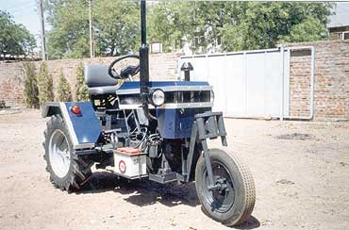

RURAL INNOVATORS
Bhanjibhai Mathukia
Kalawad, Gujarat
HARESH PANDYA

When Mathukia was trying to build his tractor in the early 1990s, fellow- villagers would laugh at him."I used to experiment with whatever was readily available, the front tyres of a car, rear wheels and gear box of a jeep, a stationary speed diesel engine, and so on." But Mathukia is having the last laugh. His Vanraj has just received a patent in the US. It’s a unique tractor as it is convertible into three wheels from four, and has a variable track width."It can perform almost all functions expected of a large tractor, though on a small scale. Unlike the 24 HP tractor, it doesn’t consume much diesel and is perfectly affordable," says Mathukia. Vanraj may be just the thing for poor farmers with small land holdings.

"I’ve several other innovations up my sleeve," says Mathukia. Innovative designs of check dams, so vital in dry Saurashtra; a modified seed drill; a small bullock-operated pesticide sprayer; a semi-circular check dam-like design for the construction of water storage tanks for household and agricultural use. Recipient of several awards for innovation, member of an Indian delegation invited to South Africa to guide farmers and artisans about new technologies and innovations, Mathukia remains, at heart, a son of the soil. "I will be happy when small farmers benefit from Vanraj," he says.
Sanket V. Chitagopakar & Prashant V. Harshangi
Gulbarga, Karnataka
SUGATA SRINIVASARAJU

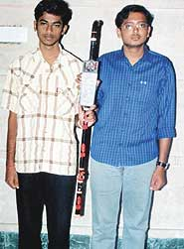
The two reticent teenagers from Karnataka’s Gulbarga had developed an electronic stick for the visually challenged a few years ago. The intelligent stick is a PVC pipe. At one end there are three light-emitting diodes (LEDs), on the left, right and one in the front, with three sensors placed above each. Infrared light from the LEDs hits the obstacle, bounces back to the sensors and converts into electrical signals that trigger the circuit placed at the stick’s handle. The circuit converts the electrical message into sound—each sensor producing a different sound—to alert the user. "The whole process takes one millionth of a second. Obstacles can be detected in the radius of five metres," say the duo.
And, an electrode-based moisture sensor at the stick’s front end is a puddle-detector!

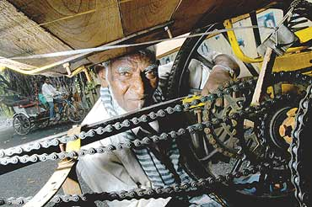

RURAL INNOVATORS
Sheikh Jabbar
Nagpur, Maharashtra
SAUMYA ROY

He studied only till class four and has been a cycle-rickshaw plier since his teens. It was his failing health that inspired him to create a gear system to power his rickshaw. When Jabbar pulls the worn strings attached to the handle, he presses one of his four gears into service. So, while other rickshaw pliers get off and drag their vehicles up an incline, Jabbar just drops the gear to allow his rickshaw to glide up.
For 15 years, he saved money and built up courage to create the gears. Then over 10 years, took his rickshaw apart and rebuilt it with discarded parts, first with two and then four gears."People used to think I was mad when I told them what I was doing." Now, Jabbar has used a motley set of discarded parts to build a rickshaw where both wheels move and has four gears.
Jabbar has driven his rickshaw to Delhi and Wardha and has won an award from the National Innovation Foundation. There are a couple of rickshaws running in Nagpur and Jaipur to check if his model can be scaled for wider use. He estimates that his simple innovations would add just Rs 2,000 to the cost but would drastically reduce physical stress for millions of rickshaw drivers around the country.Meanwhile, he is ready with a new idea. He has fitted a rickshaw with a small engine to power it up inclines. To test this, he wants to drive it to Ahmedabad.
Today, his vehicle is recognised on the streets and feted. Many times he has to assure his woman passengers that it’s not her but his rickshaw that is inviting the stares.

RURAL INNOVATORS
Arvindbhai Patel
Vanch, Gujarat
HARESH PANDYA

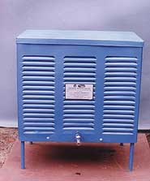
Patel quit college after "wasting a year" studying commerce. "The English medium of instruction was a big problem and a good excuse!" Companion, the auto air-kick pump Patel has invented, helps inflate tyres using the built-in kick-start mechanism of a two-wheeler. "It is designed keeping in mind those who regularly travel miles on motorbikes." The compression of air obtained while cranking up the engine cylinder is transferred to the tyre tube with the help of this instrument. You’ve to unscrew the spark plug and keep the petrol cock closed. Then the adaptor of the device is screwed onto the spark-plug while the other end is clamped onto the tyre valve. A few kicks, and the tyre inflates. Using a coiled copper pipe covered with a damp ribbon, Patel has managed to create a natural water cooler, based on the principle of vapour absorption. The cooler has been developed in three different capacities of 5, 10 and 20 litres. Then there is an auto compression sprayer that uses the normal body movement of walking as an energy input to accentuate the to and fro movement, which in turn drives a piston that generates enough pressure for spraying. "The farmer feels relaxed, rather than drained of energy, after using this device," he says.

Wife Jayshri, a schoolteacher, initially resented his passion; it was all expenses, no returns. Now she calls him a "genius".

RURAL INNOVATORS
Remya Jose
Nenmani, Kerala
JOHN MARY

She is just 18, and she has applied for a patent for her non-electric washing-cum-exercise machine. All you need is to pedal. Forget the power cuts. You get your clothes washed and dried, with less damage to them than in a conventional electric gadget. And you would have also burnt a few calories at no extra cost.
A rust-proof mesh cylinder inside a metal box is connected to two pedals. Put the clothes in the box, add detergent, fill half the box with water, and pedal for four minutes. The cylinder moves fast enough to scour off the dirt with constant beating against the mesh. Rinse, and clothes are dried 80 per cent. Cost: Rs 3,000. For another Rs 2,000, a cycle with a seat can be added on.
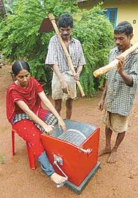
Remya’s father, P.A. Joseph, once turned down her request for a washing machine. Since then Remya’s thoughts hovered on a machine that works on mechanical energy. Several sessions with the local mechanic yielded a simple machine. The parents couldn’t have asked for more. "She studies well, has won prizes in elocution, essay-writing, short story, mono act—she also learns her catechism well," says her father. Remya, of course, brims with ideas: a smokeless oven, a vacuum cleaner that uses water.... Meanwhile, if the washing machine patent is accepted, she hopes she will have enough funds to pursue an electronics engineering degree in a reputed college.

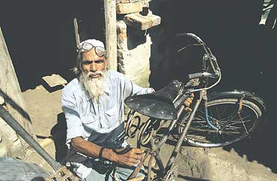

RURAL INNOVATORS
M. Saidullah
Mathia Dih, Bihar
FAIZAN AHMAD

The "Noor bicycle" is special. It’s an ordinary bike, but becomes a cycle boat in water. Imagine a conventional bike with a few extra attachments—four rectangular air floats and fan blades attached radially to the spokes of the rear wheel; the floats keep the bicycle from sinking and the blades, when one pedals the bike, allow forward movement.Mohammad Saidullah’s amphibious bicycle has been praised by President Kalam who noted it could be useful for defence personnel too.
On the president’s instruction, the bicycle was kept by the National Innovative Foundation for further study and development. Noor was Saidullah’s late wife, and he names all his innovations after her.The 66-year-old has built a fan that runs without power, a mini-tractor for transporting materials, a fodder cutter-operated centrifugal pump with discharge capacity of 10,000 litres per hour and a mini-turbine for electricity generation. The idea of making the bicycle came to him when his village got marooned during floods. But there are no takers for his ideas.
"I know there is no value for my innovations," says a disappointed Saidullah, who sells honey, earns a mere Rs 1,300 a month. All his trophies and citations, including one awarded by the President, are rusting. He recently received a Rs 1 lakh cash prize—he has spent half of it on developing an amphibious cycle-rickshaw and the rest on clearing loans. But he still has three new ideas: to develop a bicycle that will run 100 km without any manual labour, an automatic mini electric powerhouse which could light up four bulbs or run four fans for 24 hours for a whole year without any expense and a mini-car that would run without petrol or diesel.

