Chapter 8

Networking Knowledge Rich Economically Poor People

Anil K Gupta, Brij Kothari, and Kirit Patel

Indian Institute of Management, Ahmedabad 380015. Email: anilg@iimahd.ernet.in

Indian Institute of Management, Ahmedabad 380015. Email: brij@iimahd.ernet.in

Honey Bee, C/o Indian Institute of Management, Ahmedabad 380015
Email: honeybee@iimahd.ernet.in

Barriers of literacy, localism, and language impede lateral learning among creative communities. The inability of formal science and technology institutions to add value to local innovations further reduces the potential that grassroots green innovations may have in making society more sustainable. Conventional textual and printed information based knowledge networks created by the Honey Bee Network have helped create a community of interested stakeholders building bridges between formal and informal knowledge systems. This paper describes the use of the multimedia and multi language Honey Bee database in overcoming some of the constraints of conventional knowledge networks. It shows how the Honey Bee Network database—developed by the Society for Research and Initiatives for Sustainable Technologies and Institutions (SRISTI)—can influence public policy so that local communities and individual innovators are empowered and enabled to learn from each other across large spatial distances, languages and cultures; without being literate.

1. Introduction

The decline of the welfare state in the developed world has in recent times been accompanied with the denial or ‘unfeasibility’ of similar pursuits in developing countries. Squeezed by structural reforms, a lack of new social imagination is as much a commentary on the state of our civic consciousness as it is on the fragility and bankruptcy of our intellectual apparatus drawn from the legacy of the Marshal Plan and ‘do gooding’ state bureaucracies. We now need a new paradigm of envisioning social change and development built around overcoming information asymmetries. Knowledge can become a means of power if coalitions or networks of relevant actors evolve. The chemistry of evolution of such networks, which connect information, institutions, and incentives with innovations and enterprises, is the subject of this paper.

The French philosopher, Abbe Pierre, argued that modern (read “Western”) society is confronted with three realities. First is the growing power of media and travelling which deny civilized society an excuse of not knowing; the second deals with obligation of developed countries to deal with the rising problems of unemployment by reducing working hours; and the third refers to the challenge of utilizing enormous free time. I argue in this paper that every time information and communication technology (ICT) reduces information asymmetries, it can also help increase responsibility. One can no more make an excuse of not knowing for non-intervention since, as I illustrate with the example of a Knowledge Network/Centre approach to augment grassroots creativity, ICT also helps align key actors in civil society. The alienation, fragmentation, and dislocation of knowledge space make it difficult for creative urges of society at the grassroots level to coalesce. Market forces, as these have evolved, are generally successful in bringing together certain interests at specific scales. However, market failure is evident when transaction costs are high. Investment in ICT infrastructure can help to reduce these transaction costs for those whose ability to pay for them is low. But this will not happen automatically. Just as paving roads in forests often leads to accelerated deforestation, ICT infrastructure can lead to quick erosion of local knowledge and wisdom unless appropriate institutional interventions are made simultaneously.

- Legacy of development

The developmental paradigm has been dominated for at least half a century by the idea that the role of state or civil society is to provide the poor with material resources, and opportunities for skill or income augmentation and employment. Strategies have never been built upon a resource in which poor people often are rich, i.e., their knowledge. Indeed developmental lexicon in the last decade adopted a term with great alacrity – ‘resource poor people’, assuming that ‘knowledge’ is not a resource. This blemish can be traced in almost every major developmental writing. Once knowledge is recognised as the fundamental building block of developmental options for disadvantaged communities around the world, the role of ICT becomes conspicuous in this envisioning process.

- Incentives and ICT

Information and communication technology can be harnessed to generate incentives for knowledge rich economically poor people to share their knowledge without exhausting their Intellectual Property Rights (IPRs) and creating fear of being robbed of their only resource. It can do so by providing a global registration system such as INSTAR discussed later. ICT can also hold together, institutions for conservation, particularly when the need for horizontal flow of information among communities facing different challenges is very high.

The greater the specificity of environmental challenges, the more likely it is that local knowledge systems will be isolated and fragmented. And yet analogic learning systems thrive precisely on such dissimilarities and discontinuities of knowledge systems. Fragmentation of knowledge space takes place due to various social divisions and cleavages, discontinuities in inter-generational transfer of traditional functional knowledge, and incommensurability between knowledge and the accompanying ecological and other resource contexts. Fragmentation can also arise if contemporary innovations for resource use are not shared widely. This may either be due to the dominance of external knowledge systems or due to contempt for local and familiar knowledge as happens in many communities and societies. The analogic learning can help overcome many of these discontinuities by helping: (a) search for solutions in different contexts; (b) provide clues about the kind of relationships that can be pursued; and (c) enrich the repertoire of local communities and innovators so that they can independently locate ideas for solutions as well as alternative materials. The basic idea of such analogic learning systems, is, for example, that even if fish are not found in dry regions, knowledge about another community using plants to numb fish before catching them, may trigger some other uses of toxic plants in a pastoral community, say, for veterinary medicine.

- Some observations

While ICT can provide a mechanism to abstract and exchange information on the heuristics underlying innovations, it has its limitations. For instance, the ethical values which encourage sharing of knowledge at the local level are also accompanied by general contempt or indifference towards local innovations in many societies. This paper provides some practical ways in which low cost ICT applications have provided incentives for sharing local innovations and establishing institutional mechanisms for the production, reproduction, exchange and critical (but appreciative) peer evaluation of knowledge systems for sustainable resource use.

Knowledge systems that enable people to survive, particularly in high risk environments, have involved blending the secular with the sacred, reductionism with holism, short term options with long term ones, specialized with diversified strategies; involving individual or collective material or non material pursuits. Classical dichotomous approaches have seldom worked. The environmental ethic of these communities have also reflected these blends contrary to the populist rhetoric of so called unitary approaches with one kind of strategies say, for instance, holistic ones dominating and displacing reductionist ones.

The higher the stress—whether physical, technological, market, or socio-economic—the greater the probability that disadvantaged communities and individuals will generate innovative and creative alternatives for resource use. Innovations, whether originating in traditional or contemporary consciousness, can develop from communities as well as from individuals. An over emphasis on community development to the exclusion of contribution of individuals may have lead to the widespread indifference towards tapping the potential of knowledge rich economically poor people.

The ICT needs in areas where the majority of households are managed by women will be quite different from those dominated by male decision makers. The health needs, agricultural systems, technological challenges and interface between cultural taboos and economic pressures will be most acute in these areas. Knowledge networks can generate new choices by connecting one group of women, who may have overcome some socio-cultural contraints to their economic improvement, with another group that is struggling to do so.

ICT can either help bridge or widen the gaps between haves and have nots. What is encouraging about the new possibilities that ICT trends offer is the scope for democratizing knowledge. The multimedia database conceptualised by SRISTI and the Honey Bee Network demystifies the technology to empower local communities and innovators in rural areas. In the process it also democratises knowledge through horizontal networking.

Finally, innovations in technological, cultural or institutional subsets often remain isolated and unconnected despite the existence of reasonably robust informal knowledge networks.

- The Honey Bee Network and Multimedia database

A knowledge network that connects innovators, enterprises, and investments (see Figure 8.1) in an institutional context appears to be the most viable approach for future sustainable development. The points of departure for the Honey Bee Network, which began ten years ago, were: first, we, the outsiders, should not make the poor complain when we take away their knowledge just as flowers do not when bees take away nectar; second, we should connect people to people as bees connect to other bees while pollinating. The genesis of the Honey Bee Network lies in a self-critical realisation that the first author faced while looking at his own work drawing upon insights gained from creativity and innovation at the grassroots level until the mid 1980s. Gupta had grown in his career but his accountability towards knowledge providers had not been adequate. Much of his work had been published only in the English language. Income increase due to various honours and professional rewards had accrued to him. He reasoned that his contribution towards policy and institutional reform was in a way reciprocal towards disadvantaged sections of society. He realised his conduct was not too far removed from other exploiters in society. Traders, money lenders, and other landlords extracted undue rent in the respective resource markets. Intellectuals did the same in the market of ideas.

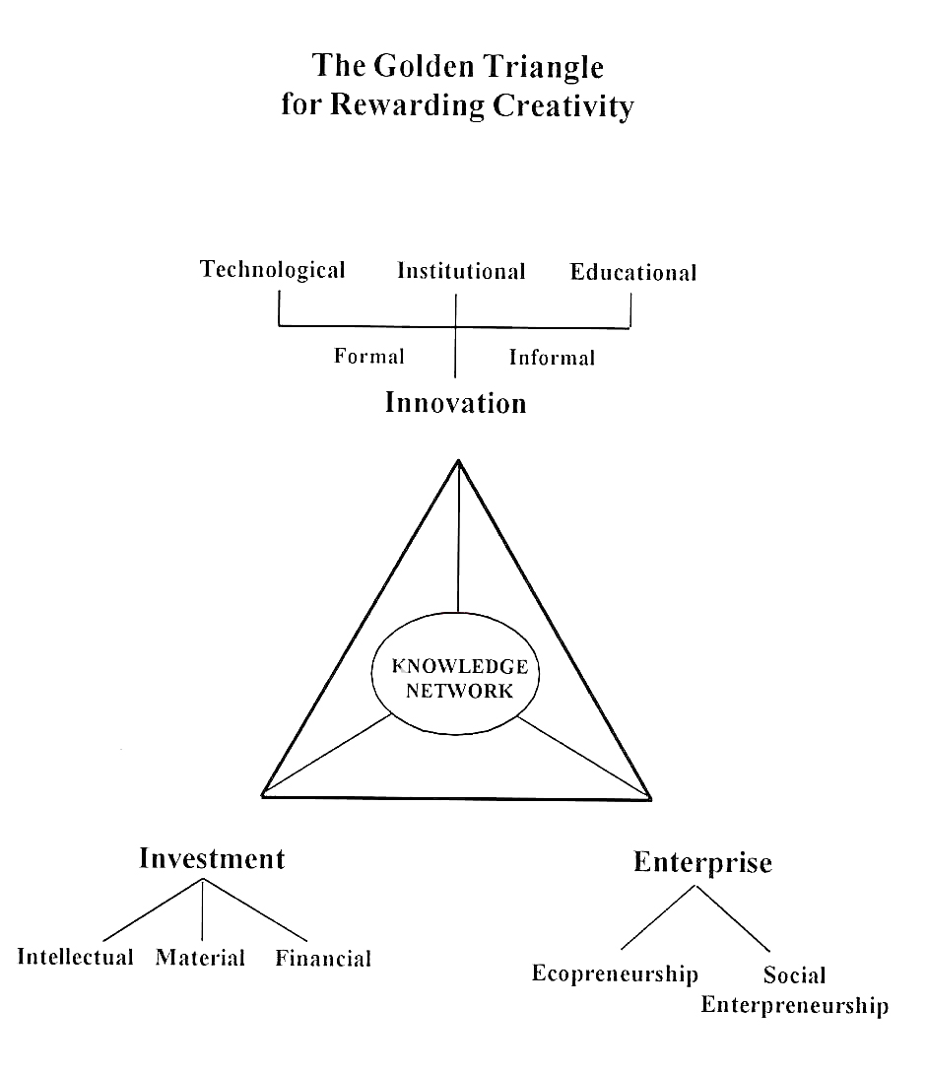
This initiated Gupta and many of his former students and colleagues to establish the Honey Bee Network. It was evident that whatever they learnt from people must be shared with them in their own language. Hence the emphasis on sharing findings in local languages using various media. Since the printed word would reach only literate communities, use of multimedia and multilanguage technology was indispensable.

Figure 8.1 The Golden Triangle for Rewarding Creativity

Further, it was also decided that people to people communication can take place only when creative individuals and communities can learn in their own language. The Honey Bee newsletter is at present being brought out in six languages and we shall endeavor to make communities around the world connect with each other in their own language through link language database system and communication networks. To generate mutuality, trust, reciprocity and responsibility, the Honey Bee Network decided that no individual gains will be made by use of the Honey Bee database. Thus individual consultancies are ruled out. Likewise, whatever income accrues must be shared in a reasonable manner with the providers of knowledge. Obviously, these goals and underlying principles are not easy to accomplish. The fact that the database has been growing and in many cases innovators have been seeking us out indicates that societal confidence in our philosophy is increasing. Slowly these values might become the standard practice of the profession.
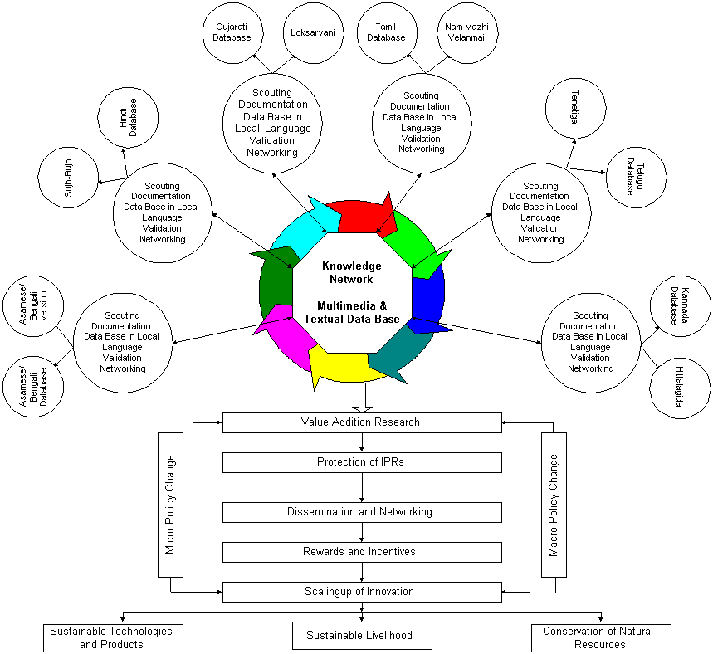

Figure 8.2 Knowledge Network Multimedia and Textual Database

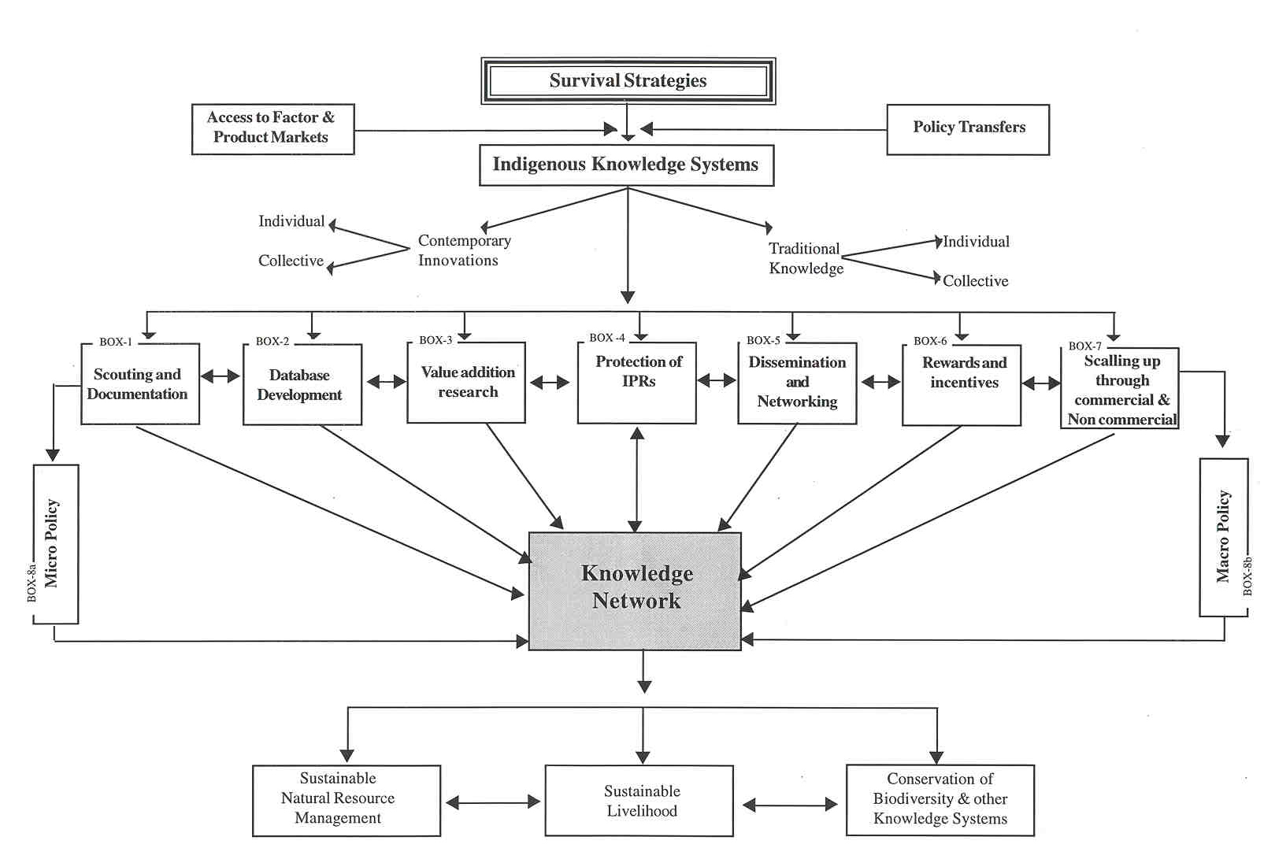

Figure 8.3 Framework for Understanding and Augmenting Grassroots Innovations

A voluntary organisation, SRISTI (Society for Research and Initiatives for Sustainable Technologies and Institutions) was set up in 1993 to strengthen the Honey Bee Network in different parts of the country. SRISTI supports the Honey Bee Network by linking six E’s, i.e., ethics, equity, excellence, environment, education and efficiency in enterprise.

The operational framework developed to pursue the goals of the Honey Bee Network is shown in Figure 8.2 and Figure 8.3. The figures show how contemporary as well as traditional innovations are scouted, screened for experimentation for value addition or dissemination, and then rewarded through various material and non-material incentives to individuals and collectives. Policy support at macro as well as micro levels becomes important for conversion of innovations into products and eventually into sustainable resource use. The networking of various strategies, actors, and institutions through the Knowledge Network leads to sustainable livelihoods apart from mechanisms for conservation of resources and knowledge around it.

There are eight modules in this framework involving the value chain from documentation to its eventual dissemination and benefit sharing: (1) scouting and documentation; (2) electronic textual and multimedia data base development; (3) value addition research; (4) protection of intellectual property rights; (5) dissemination and networking; (6) benefit sharing, rewarding and compensating individual and collective innovators; (7) scaling up of innovations and commercialization; and (8) policy changes at micro and macro levels.

The Indian Institute of Management in Ahmedabad (IIMA) has played a significant role in the evolution of the Honey Bee Network. Policy mediation, networking, conceptual development, and many other activities have been developed here. The role of SRISTI is to help pursue those goals where action at the grassroots level becomes imperative and also where advocacy positions have to be taken. In addition, support to innovators, particularly financial or technological and research in farmers’ fields or laboratories, is pursued through SRISTI. A large number of volunteers at all levels support the activities of the Honey Bee Network.

Three examples of policy breakthroughs through the collaborative programme between the IIMA, SRISTI and the Honey Bee Network are worth mentioning here:

a. Establishment of Gujarat Grassroots Innovation Augmentation Network (GIAN)

As a follow up of the International Conference on Creativity and Innovations at Grasroots organised at the IIMA in January 1997, the Gujarat Government helped in setting up a fund through partnerships between civil society, state government and academic and corporate institutions. GIAN has been trying to scale up the technologies that have been utilised by the Honey Bee Network for the database maintained by SRISTI.

- Presentation to the Prime Minister’s Taskforce on IT

An invited presentation on multimedia database to the Taskforce was well received and a sub group on content for IT applications drew upon this experience for developing national strategy.

- Establishment of National Innovation Foundation (NIF)

A presentation of multimedia databases on April 26, 1999 to policy makers in the Ministries of Finance, Science and Technology, Departments of Scientific and Industrial Research, Agricultural Research and Education, and articulation of the concept in the pre budget meeting with the Finance Minister led to the following announcement in the GOI budget speech:

“Jai Vigyan is the tribute so aptly paid by our Prime Minister to hail the achievements of our scientists. The time has come to unleash the creative potential of our scientists and innovators at grass roots level. Only then we can make India truly self-reliant and a leader in sustainable technologies. I propose a national foundation for helping innovators all over the country. This Fund, with an initial corpus of Rs.20 crore, will build a national register of innovations, mobilise intellectual property protection, set up incubators for converting innovations into viable business opportunities and help in dissemination across the country.”

The NIF will try to replicate the experience of the Honey Bee Network, SRISTI and IIMA in scouting, spawning and sustaining grassroots innovations. The application of information technology will be a very vital component of NIF’s strategy.

Knowledge Network for sustainable technological options operationalised through the Honey Bee Network implies that innovations in one part of the world may seek or attract investments from another part, if necessary, to generate enterprises (whether commercial or non commercial, individual or co-operative) in a third place. Several innovative experiments have been started to explore this Golden Triangle for rewarding creativity. It requires acknowledging that not all innovators may have the potential for becoming entrepreneurs or have access to investible capital. One could have an innovation say from India, investor from Europe and enterprise in South Africa.

- Application of the Multimedia database

The Honey Bee database with thousands of innovations has been upgraded to multimedia capabilities so that barriers of language, literacy, and localism are overcome to connect innovators, potential entrepreneurs, and investors across regions. By using electronic, textual and oral media, a multi-language, node network allows individuals as well as collective grassroots innovations to be documented, experimented, disseminated and rewarded in material as well as non-material manner.

Much is said about participatory research and millions are spent in augmenting capacity of formal institutions to ‘learn from people’ (unfortunately using short cut methods which are neither accountable nor ethically very sound or even scientifically very efficient). However, not even a fractional amount is spent in augmenting the capacity of innovators themselves to do research, take risks, and generate new enterprises themselves or through partnership with other entrepreneurs. Multimedia database makes it possible for innovators to become self reliant through horizontal networks.

- Specific features of the database

The database includes empirical illustrations of how small farmer men and women have developed innovative solutions to local problems through their own genius without any outside help. In addition to innovators who have generate contemporary solutions, we have examples of experts who have used traditional knowledge with relevant modifications for solving problems. Many times, there is a confusion among the people to imply that: (a) all local knowledge is traditional; and (b) it is contributed and maintained by the communities. Our database shows that this is not true. There are a large number of individuals who have thought of a unique solution to a persistent problem or a new problem. The need for recognising individuals cannot be over emphasised if we want our society to become creative, meritocratic and willing to reward experimentation and innovation. There is no other way any country can become globally competitive. Further, these individuals will also act as role models to inspire the younger generation to be even more innovative.

The first screen provides entry to the database as well as a window on SRISTI. The database is in three languages, English, French and Gujarati. The French language was chosen to demonstrate global implications of the database. The first Global Knowledge Conference organised by the World Bank in 1997 was held in the French speaking part of Canada where the database was first displayed.

The second screen introduces the viewer to various categories of innovations. In each category there are several innovators whose names and innovations are profiled. The viewer can press a button on any of these to reach the page of that innovator. The first page of every innovation (Figures 8.4 and 8.5) has a photograph of the innovator, the innovation and a brief profile of both. If there is more than one innovation, these are displayed through additional buttons. The language button is available on every page so that the viewer can switch between languages.

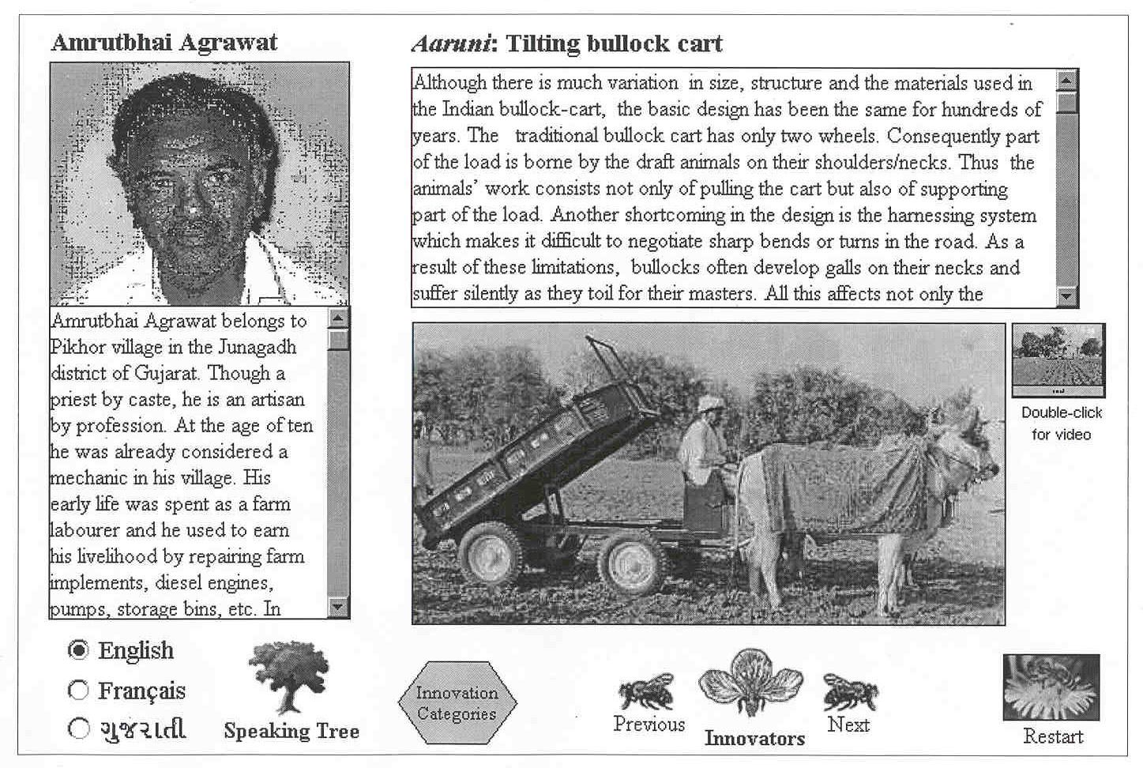

Figure 8.4 Amrutbhai Agrawat, an innovator with his innovation

The most important feature of the database is that it integrates sound, picture, film and text in such a manner that an illiterate farmer can also listen to the voice and see the innovation in action to understand it. We have shown this database at several places such as the Shodh Yatra, fairs in villages and towns, informal village meetings, and in educational and policy institutions. The immediate impact of a multimedia database is that it is quicker and more apparent than textual databases.

8. Other impacts

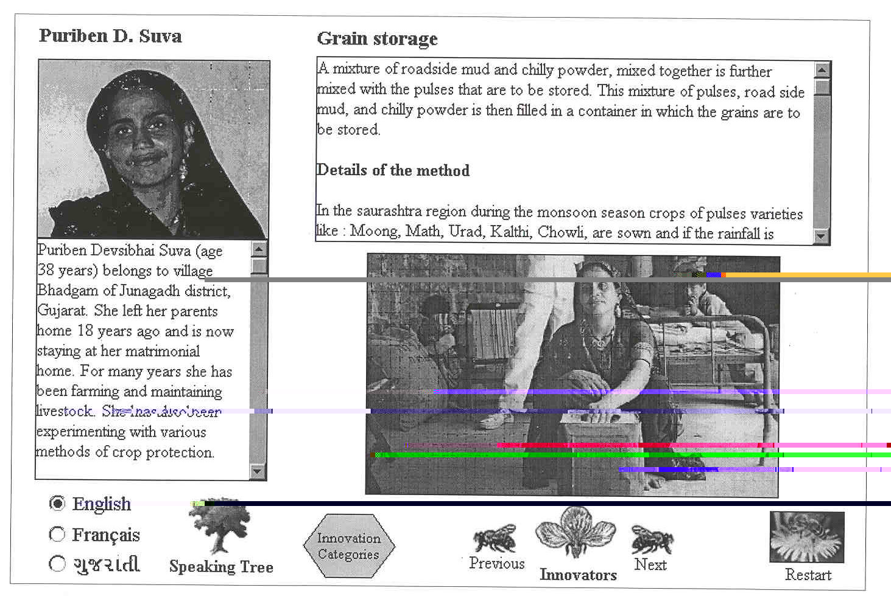
When farmers see the faces of people like them doing extraordinary things, they certainly get inspired, as it is easier for them to identify with them. The impact of the innovators is even more profound in the village. The entire community seems to take pride in the fact that one of them is profiled in the database which people see in other parts of the country as well as around the world. It spurs them to bestow more

Figure 8.5 Puriben D. Suva, an innovator with her innovation

recognition on their own fellow farmer innovator. On meeting tribal and other communities, the access to database often generates a question as to why a particular expert from their community is not there in the database. The demand for being scouted, catalogued and recognised helps extend the goals of Honey Bee Network immediately. Often, the innovator whose profile people watch, walks along the rest of the group in Shodh Yatra. This gives an opportunity to the people to talk to such an innovator and thereby demystify the technology as well as enhance the process of lateral learning.

There is a recognition and realization that innovation matters and that too by unsung heroes and heroines. When herbal innovations are discussed, a slow but significant revaluation of the role of local knowledge experts, herbalists etc., takes place in the local context. The same healer who so far appeared powerless, a philanthropic do gooder, is seen by some as an expert worthy of respect by outsiders.

Exposure to the Honey Bee database also generates a desire to experiment, particularly, when pest control or veterinary medicine innovations or outstanding traditional knowledge is discussed.

There is an observed demand of some of the local innovative products and services. This particular impact has been very significant for some innovations such as the tilting bullock cart or a simple device to fill nursery bags or an improved pulley for drawing water. The transformation of ordinary initiatives into extraordinary innovation takes place when people realise that they have lived with an inefficient or less efficient solution (for millennia as in the case of the water pulley).

Overcoming inertia among potential innovators: In some of the villages, when we showed the database to large number of people with the help of an overhead projector, we asked the farmers and artisans to share their own experiences. Occasions when there was total silence were overcome on our insisting that we would show our next card only when they will reciprocate by sharing some of their own innovations. In Hirenvil village near Gir Lion Sanctuary in Gujarat during the night discussion, several ‘unsung’ heroes were discovered. One person had developed a lock system to unwind and lift a damaged submersible pump from underground--a task which is difficult and labourious. Likewise, in the village of Bhanjibhai, a person who had developed a three wheel 10 HP tractor and a local herbalists who had developed some innovative solutions volunteered to share their experiences.

One of the unfortunate impacts has been that except in some villages, women generally sit in the rear or farther from the place where we display the database. Therefore, we have to take the notebook computer to them (Figure 8.6) so that they don’t feel deprived of the exposure and at the same time, have the opportunity to share their own creativity. In the village Nandapur, Dist. Vadodara, when the database was shown to the women they immediately identified Ataben Shantilal Bariya, an expert women who made outstanding grain storage bins. We must acknowledge that our database is much weaker in terms of women’s innovations--something we are trying to overcome in the next phase of our action research.

9. Future issues of concern

We can help strengthen people to people learning only when we ensure communication in local languages and media. The Honey Bee Network has created new standards of accountability and ethics in dealing with grassroots innovations. The formal sector can not use the knowledge of poor without acknowledgements, citation and ofcourse prior informed consent—a notion we argued before the Biodiversity Convention came into existence. Similarly, the documentation and dissemination of these innovations must take place in local languages and without exhausting IPRs of these communities and individuals. For the latter, we propose that the INSTAR system is institutionalized by the WTO as well as Convention on Biological Diversity (CBD) so that the International Network for Sustainable Technological Applications and Registration becomes part of the Knowledge Network for augmenting coping strategies of the poor in a creative manner.

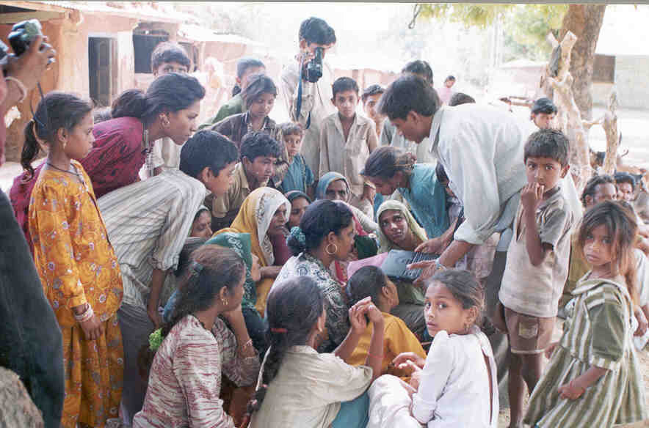
In a recent paper, Gupta argued that the publication of local knowledge exhausts IPRs on one hand, and on the other, may deprive the knowledge provider any benefit that may arise from value addition in local knowledge to the individual or community or nation concerned. At the same time, local language publications make it possible for people struggling with similar problems to learn from it. This happens through publication in local languages as attempted by the Honey Bee Network. However, the challenge is to marry the two goals of easy and quick opportunity for lateral learning (through local language publication), and sharing of benefits through value addition in the same knowledge.

Figure 8.6 Display of database to women using notebook computer

Legitimizing to databases like Honey Bee and a registration system of innovations may provide the answer. Such a registry will prevent any firm or individual to seek patent on community knowledge as well as on knowledge and innovations produced by individuals without some kind of cross licensing. Honey Bee will then make its databases accessible to all patent offices in lieu of the protection provided to the communities and individuals whose knowledge is catalogued in it. The alternative of greater secrecy and withholding of knowledge will make every one lose through: a) greater erosion of oral knowledge; b) continued unwillingness of the younger generation to learn the knowledge, innovations and practices developed over a long period of time; c) depriving any opportunity to knowledge holders as well as those dependent upon them to improve their livelihood prospects through sharing of possible benefits; d) lack of material incentives for conservation of endangered species; e) knowledge rich poor communities may migrate out due to low opportunities for subsistence and employment and not take care of local resource or over exploit the resource itself netting very little value in a short period of time; and f) stifling the very creative and buoyant laboratory of innovations at grassroots by denying any social esteem for such knowledge through material as well as nonmaterial incentives and general neglect.

Since it will be very difficult for any and every community to seek protection of its knowledge and inventive recipes for various purposes such as herbal pesticides, human or veterinary medicines, vegetative dyes, etc., a registration system should be developed. Such a registry will prevent any firm or individual to seek patent on community knowledge as well as on knowledge and innovations produced by individuals without some kind of cross licensing.

Disentangling the relationship between literacy, education, knowledge, and wisdom may spur education processes for young and old if access to the database lasts longer. A suggestion is often received as to why such a database could not be based in a local school or Panchayat office. The demand for decentralised access to databases on local creativity, if harnessed, can erode the inertia and charge the local imagination to try and improve things with their own efforts. The democratic, polycentric polity requires a large number of self governed nodes not just receiving solutions but also generating and sharing solutions. The next step in the Honey Bee multimedia database will be when local innovators would be able to not just retrieve information but also feed in their own innovations to get comments from their peers, seek intellectual property rights protection, generate demand for their services or products or even get enquiries from potential investors or entrepreneurs interested in joining hands with the innovator to scale up the innovation. The lack of education may not come in the way. In fact, the demand for education to master such technologies may increase.

10. Conclusion

The Honey Bee multimedia database has taught us a great deal about demystification of information technology and its use for empowering local communities and within them the creative women and men. We are convinced that this technology if applied properly with the right kind of sensitivity to local cultural and ecological diversity, can transform the capacity for imagination and experimentation. A great deal of discussion today on sustainable development is top down, one way, and often based on information and alternatives produced by the formal sector. The Honey Bee database has demonstrated that by building upon the knowledge of the poor people, we can not only enrich local repertoire of ideas but also trigger initiatives some of which may transform into innovations. Whether institutional capacity to respond to these innovations will also simultaneously increase could depend upon the emergence of horizontal knowledge networks managed by local communities and individual innovators, aided by the volunteer scientists, IT experts, media planners and educationists.

The Honey Bee metaphor can indeed make a difference if it can permeate our vision for promoting learning, experimentation, innovation and institutional transformation at the grassroots.

This paper is a modified and updated version of a paper invited by the infoDev program of the World Bank sponsored Global Knowledge Conference, June 22-25, 1997, Toronto, and later presented at the IIMA/World Bank workshop on Applications of ICT in Rural Development, March 18-19, 1999. The paper benefitted from the experience and inputs of several persons, including T. N. Prakash, Vivekanandan, S. Sharma, P. Geervani, Murali Krishna and other volunteers who generously shared their insights and innovations including Srinivas Chokkakula., Neeraj Joshi, Riya Sinha, Samir, Chandrani, Pawan Mehra, Dileep Koradia, Rajesh Patel, Unnikrishnan, Hema Patel, Vidyulata, and Amit Pandya. The volunteer team was lead by Prof. Brij Kothari. The data base is in three languages -- Gujarati, English, and French -- to facilitate people to people communication and learning. The French translation was facilitated by the Alliance Francaise.
Such roads increase the reach of loggers and also reduce their transaction costs (all at public expenses) while local tribal communities are exploited because an indifferent state fails to protect their property rights as well as livelihood options. Land alienation takes place rapidly despite laws to the contrary in existence and highly skilled tribal communities (skill of dealing with nature) are converted into the pool of “unskilled labour”. Road and other infrastructure do not empower these local communities in the same proportion as it does their exploiters.
http://csf.coloardo.edu/sristi/
Journey on foot through the forests, tribal villages, and other rural areas to scout local innovators, honour the already scouted knowledge experts at their home, and encourage dialogue among travelling conservators and innovators and local communities.

