Times of India, Ahmedabad Monday, January 9, 2006 Page No.5

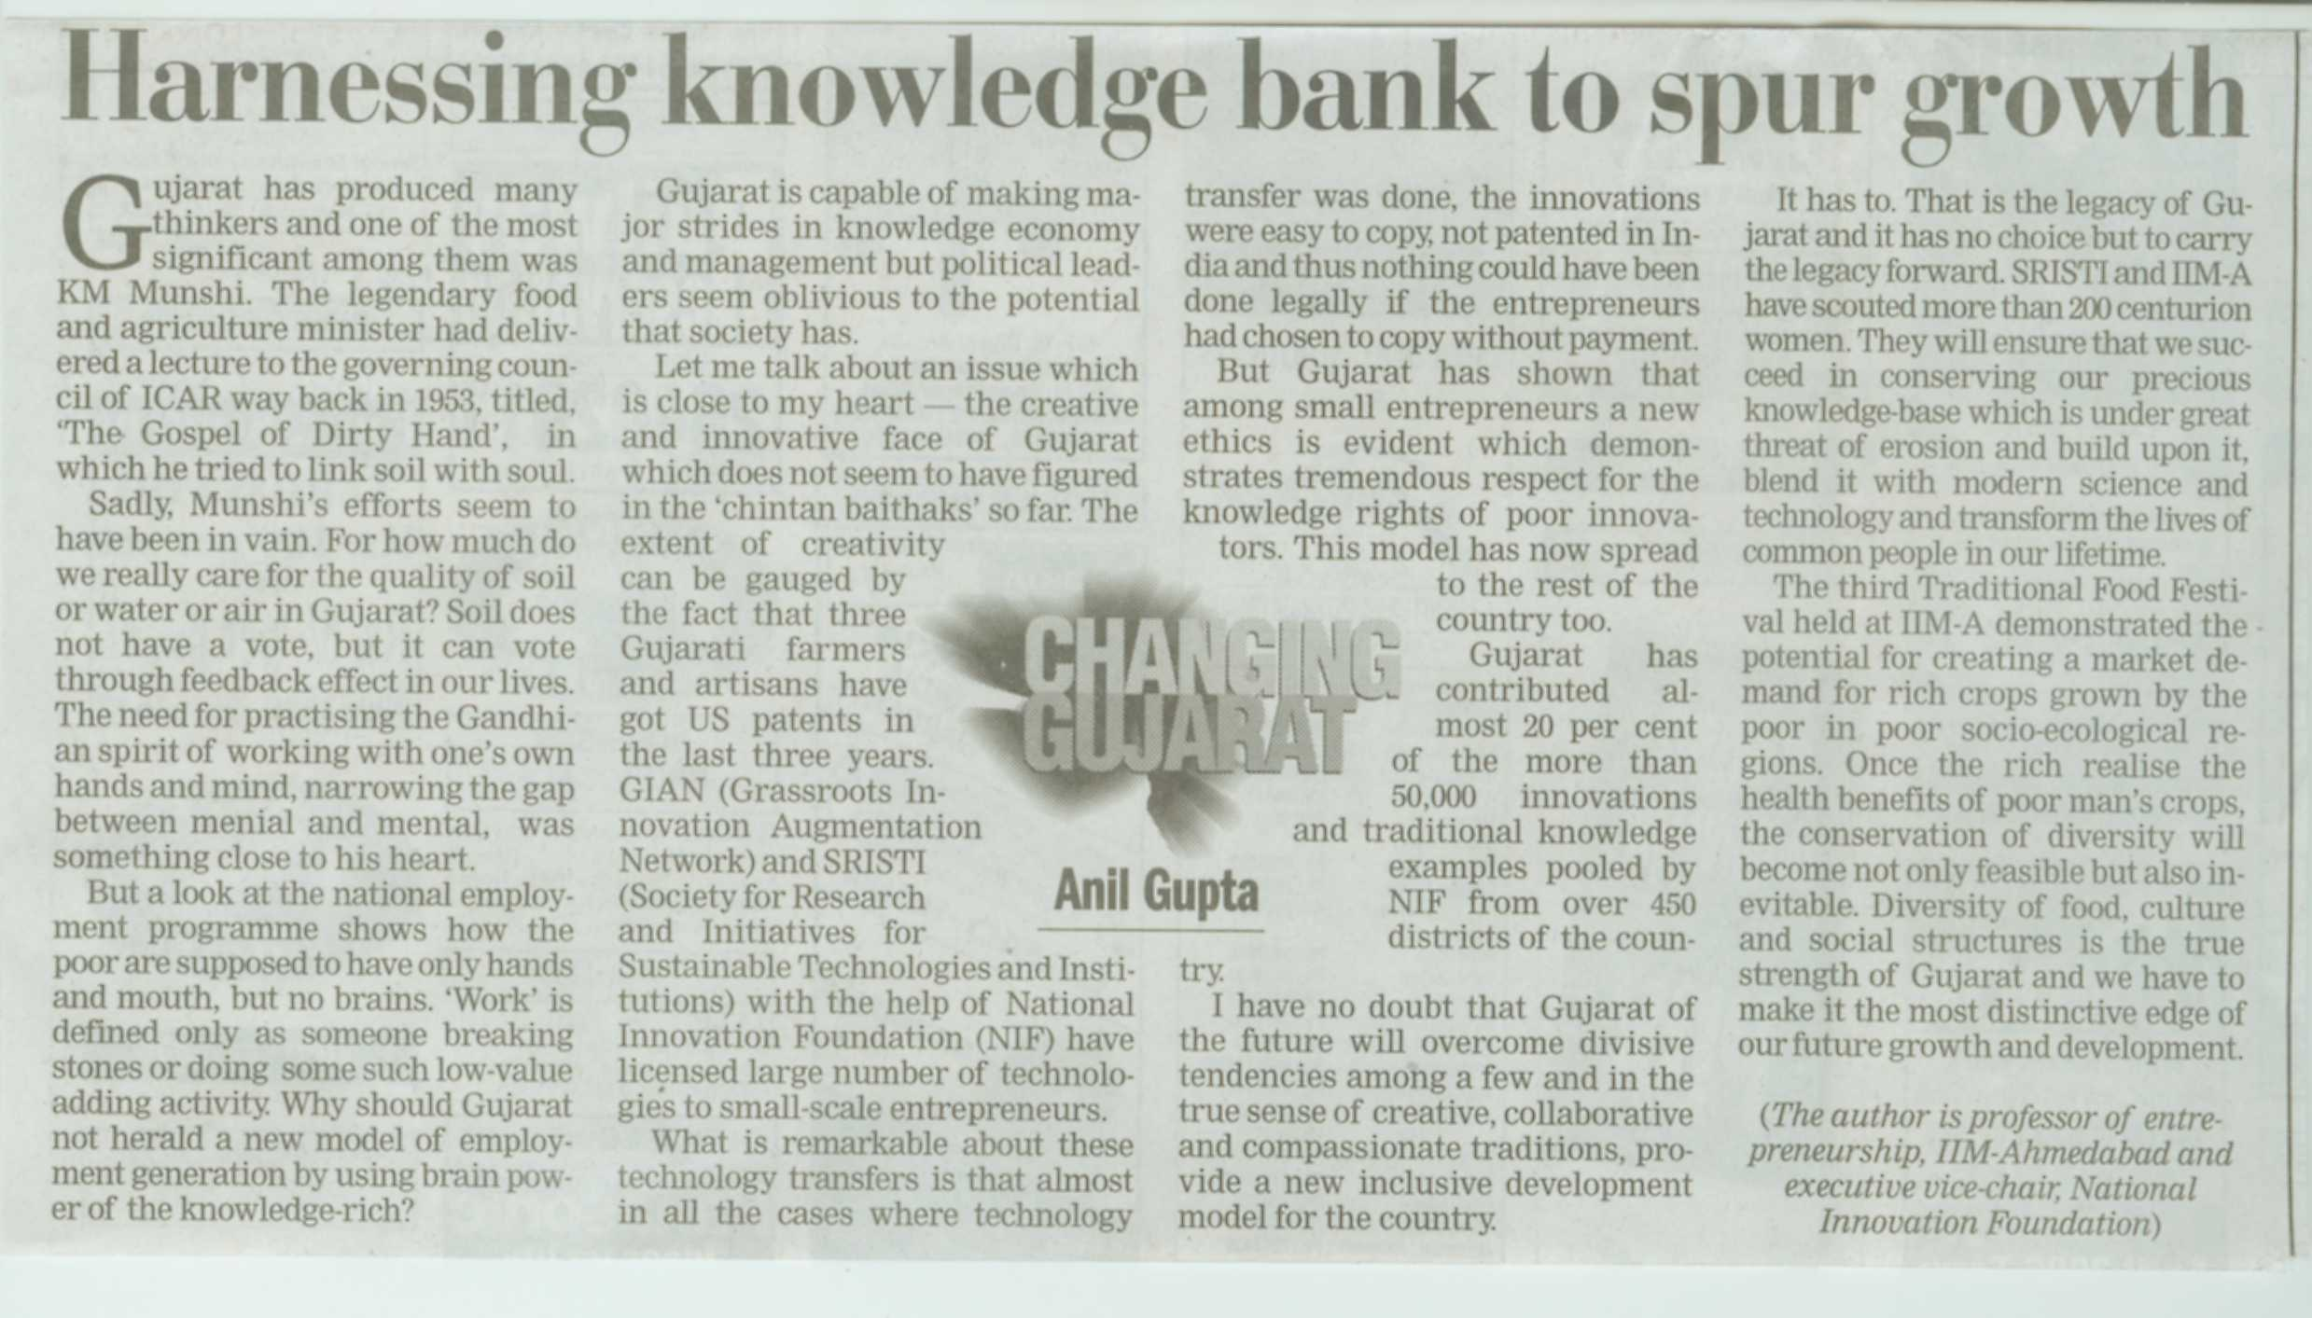

Times of India, Ahmedabad Tuesday, January 10, 2006 Page No.3

