**Grassroots Innovation**

An interview with

Anil Gupta

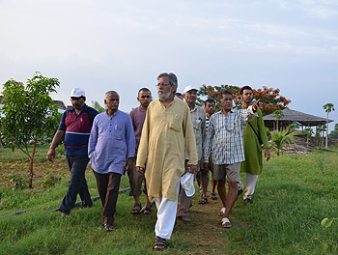

Anil Gupta, front, with members of the Honey Bee Network on a *shodh yatra* trek [Sristi.org]

*Working with the poor of India, Professor Anil Gupta was struck by the creativity and innovativeness that he saw. In 1988, he started the Honey Bee Network to discover, share and promote grassroots innovation to the benefit of both innovators and the global public.*

*One method of discovery is twice-yearly treks (*shodh yatra*) by members of the network through the rural areas of India. The network now exists in 75 countries, and its newsletter is published in eight languages. Gupta has also since established the Society for Research and Initiatives for Sustainable Technologies and Institutions (*[www.sristi.org](http://www.sristi.org)*) and the Grassroots Innovation Augmentation Network (*[www.gian.org](http://www.gian.org)*) that, respectively, help scale up and convert grassroots innovations into viable products.*

*In cooperation with the government of India, he established the National Innovation Foundation (NIF), which holds national competitions, including among children, to encourage new inventors and helps sustain them through the National Micro Venture Innovation Fund. The NIF has a database of more than 160,000 innovations and traditional knowledge practices, the largest of its kind (for examples, see* [www.nif.org.in/bd/product_list](http://www.nif.org.in/bd/product_list)*). Gupta has also established an online portal (*[www.techpedia.in](http://www.techpedia.in)*) to challenge university students to solve various problems of the poor and micro, small and medium enterprises.*

SGI Quarterly: Where did the inspiration come from to do the work you are doing?

Anil Gupta: I was working as a researcher to help scientists learn from small farmers in Bangladesh. The realization came to me that in a way I was also exploiting the people who were sharing their knowledge very generously--just as the moneylenders, traders or landlords whom I had written about for years have done in many cases. I took the knowledge, wrote about it, got a name, talked about policy and changes and all of that, but a reasonable share of my income did not go back to the people themselves. This realization was very painful, and I began to ask myself what I should do. How do I become fairer? The answer was not easy to discover.

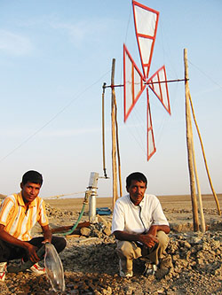

Mohammad Hussain (right) and his brother Mushtaq with one of their low-cost windmills [GIAN West, Ahmedabad]

Finally, it appeared one day--I don't know if I saw a honeybee or if it flashed in my mind, but something happened on my way from the office to home that put the thought in my mind that maybe if I become like a honeybee, life will become better.

Now, what a honeybee does is it cross-pollinates flowers. The flowers don't feel shortchanged. And the bee doesn't keep all the honey it produces for itself. Some of it is available to us and other wildlife. I realized that if we respect the creativity of the people, then we should cross-connect them in local languages. People in different regions of the world should be able to learn from each other. Secondly, people's identities and knowledge rights must be acknowledged, and third, if revenue is generated, a reasonable share should go back to these people. Now once the goal became clearer, the method became clear, the ethical values became clear; and the Honey Bee Network evolved.

The first 10 years, we were very slow. It took us about 10 years to develop and document some 10,000 ideas and innovations and traditional practices--although in the next 10 years we would get almost 150,000 ideas, innovations and traditional knowledge practices.

SGIQ: What makes some people innovators? Why do some people become passionate about changing something, when others may not?

AG: First of all, even if people don't have many material resources, they do have knowledge in abundance, and some want to use this knowledge to try things out.

We call the Honey Bee Network a network of oddballs. There are always oddballs in the world. The difference between an oddball who becomes a negative innovator like a terrorist and one who becomes a positive innovator like a grassroots innovator is that a positive innovator converts the challenge they're facing into positive action.

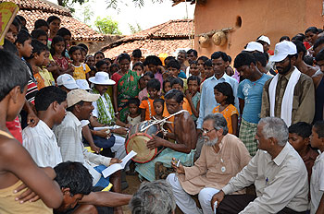

Members of the Honey Bee Network seek out local innovation in rural India [Sristi.org]

People who are innovators and people who want to destroy have one thing in common: they are very passionate. They take risks, they believe in themselves, and they can go to any extent in pursuing their ideas.

Not everybody can come up with new ideas, and that's OK. But to become an innovator, first a degree of uneasiness, of impatience with problems, is necessary.

Now the challenge is that some people may try things out, but they might not reach the optimal end. So we must link innovators with the science and technology institutions. We need to find mentors, we need to find public-spirited scientists, technologists, mechanics who will convert these innovations into next year's products--which we have done. We have an agreement with the Council of Scientific and Industrial Research (CSIR) and also the Indian Council of Medical Research for our traditional health practices.

Given that in many developing countries the popular culture is sometimes dominated by mediocrity or inertia, such people face a lot of difficulties when they try things out. People laugh at them. An innovator has to be able to bear the humiliation before they get recognition.

Every community has people who try things out. We have to look for them--whether in developed or developing countries. I cannot say that by filling out a form one can find the innovators, but the innovators are those who have the capacity to deviate from the norm, to disagree--they are dissenters, they try things out. Some are serial innovators who keep trying many things. Some are one-time innovators.

SGIQ: Can you describe some examples of the innovations you're talking about?

AG: Two innovators on a small farm, Mohammad Mehtar Hussain and his brother Mushtaq, designed a windmill for a cost of under 120 dollars. What's it made out of? Bamboo. The idea was to run a hand pump to pump water to irrigate a small paddy field. No big lab or big company could imagine that you could fabricate a solution at that cost for common people. In fact, European societies have lost the ability to design things frugally.

We brought the innovation from the east part of India to the west part of India, Gujarat, and modified it. Now it is a 1,200-dollar metallic windmill and can pump saline water for making salt.

Another example: When you go hiking, you might want a frothy cappuccino. You can boil water and make coffee, but it won't be frothy. Coffee-making machines are big, and they require electricity to make steam. So Mohammed Rozadeen, from Bihar in India, took a pressure cooker and attached a copper pipe to the small opening that can be controlled by a valve. You can put this on an open fire, boil the water, make steam and with the valve release the steam into the cup. And so for about 10 dollars you have a cappuccino-making machine. Now you may be in the Swiss Alps or anywhere else in the world, and if you want a cappuccino, you can have it right there. The idea is simple, but nobody thought of it before.

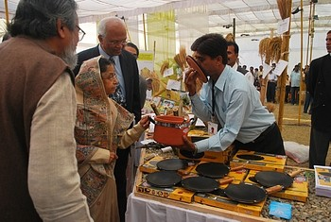

Indian president Smt. Pratibha Devisingh Patil (2nd left) examines low-cost nonstick pots and pans at an NIF exhibition; the Indian president hosts the annual exhibition of grassroots innovations at her official residence [NIF.org.in]

Let me give you another idea. You have a nonstick pan in your kitchen with Teflon coating. After you've used it for some time, the surface starts coming off and the coating material goes into your stomach and may cause cancer and whatever else. An innovator took a clay pan, coated it with edible nonstick paint, and for 2 dollars you have a nonstick pan made of clay. Now someone who could not afford a 10- or 15-dollar nonstick pan can buy a 2-dollar nonstick pan. But the thing is, because of the capillaries in the clay pan, the nonstick coating does not come off, so it is safer, as well as cheaper and more efficient.

So grassroots innovation can provide more value at less cost or, as Dr. Mashelkar puts it, these help us get more out of less for many. This is my argument: we are coming to a new point in the history of development where we will be able to ensure that we can get a better quality of life at less cost.

There are various innovations in energy, transportation (a compressed-air scooter), food processing, agriculture, textile manufacturing--you name the area, and we will have an example of problems which people have solved with their own genius.

I would wish to see a much bigger global and local engagement of designers, of fabricators, of mentors, of retired scientists who would work with the grassroots innovators and take their ideas forward. This is not about India, this is about humanity. There are creative people, and we should help their ideas go forward. You are not doing a favor to them, you are helping the community, the nation. You are delivering jobs at a time when generating jobs is becoming so difficult.

If you can make a cappuccino-making machine, what's the problem in developing a small enterprise to manufacture them? You have innovators who develop the technology, you make it open source, you have a number of people making such coffee machines around the world, people enjoy the coffee, they pay for it. Everybody's happy.

It is what I call a "g-to-G"--grassroots to global--model. We have yet to fully realize it. We've sold products on five continents, but we have to do much more, we have to go a long way.

SGIQ: What are you looking forward to next?

AG: There are four or five things that come to my mind right away. One is we should have an online multimedia, multi-language database and incubation platform so an innovation in India might find application in Indonesia, or in New Zealand, or in Samoa, or in Africa. People in that region should be able to see a video of it and should be able to understand it in their mother tongue. There is a fundamental need for what I call a global Grassroots Innovation Augmentation Network (GIAN).

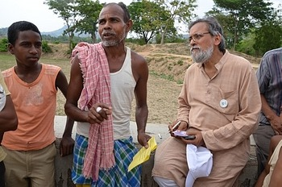

Anil Gupta, right, speaks with a local innovator [Sristi.org]

Second, I think we need to have learning centers around the world where innovators become the teachers and people around the world can see how frugal design and manufacturing is done. We should make new ways of recognizing knowledge that people have, and have the humility to learn from them.

Third, I would say that we need to have global social venture funds where people who generate new ideas--not only technological innovation but educational innovation, cultural innovation, institutional innovation--can get support and the risk capital to take them forward.

Finally, pick up any textbook, you will never find a lesson about the ordinary people who have done innovative things. But there are a large number of incremental innovations that make our world beautiful. We don't know the names of those people, but we relish so many things they have created. Somebody must have designed the backpack, but we don't know anything about them. So I think we need to have some lessons in textbooks, from school to college, which reinforce our confidence that we can also innovate.

Do you know that all the rice that we eat in our country--all the paddies are planted manually, in a very bad back-bending posture? The women, with their feet in water, walk step by step and transplant paddy seedlings. When we eat rice, we never think about the pain those women have gone through.

When we drink tea, we don't think of the pain in the shoulders of the women who pick the tea manually and then put it in the baskets on their back.

How long can we live in a world where women and men go through so much pain, so much hard struggle, and with all the knowledge that we have, all the science that we have? So I think we need to rethink our priorities, rethink the way this world lives with unsolved problems without any uneasiness, without any pain and without any guilt. We should remember, minds on the margin are not marginal minds.