Community Information Services:
A Proposal for creating Knowledge Networks for Creativity
Prof. Anil K. Gupta
Information asymmetry among people generates incentives for people to (a) build social networks, (b) negotiate various economic and social exchanges, (c) extract rent due to ignorance of some about the marginal cost of getting a particular resource or service or knowledge about alternative sources of getting that information or meeting that need, ( d) differentiate roles and responsibilities for various actions (voluntarily or involuntarily i.e. through assigned roles), (e) exploit less informed ones, and (f) create informal and formal mechanisms for information exchange, creation of knowledge individually or collectively to reduce asymmetries or the adverse consequences arising from these asymmetries. Just as some will try to reduce these asymmetries, other will increase these. Thus the challenge before designers of community information services is not to aim at reducing the information asymmetries in all aspects of one life but to build upon these so that productive and mutually symbiotic information and knowledge networks get created. Some asymmetries will and should get reduced but at the same time experience and wisdom will keep creating new asymmetries.
In this paper, I deal with the role of Information Technology which can increase the information asymmetries as well as reduce these depending upon the way we use the technology and design access to it among various community members.
The paper is divided into two parts, first dealing with the nature of community information needs and the relative efficacy of existing mechanisms to meet these, and the second dealing with recommendations about creating a knowledge network around creative communities and individual innovators.
PART ONE
Assessing Community Information Needs: Creating Demand for Knowledge that Empowers and Enables
Most communities are socially, economically and culturally heterogeneous though the degree of heterogeneity may vary from place to place and from time to time. The access to various resources, ability to convert resources into investments and assurance about future returns from present investment and about others behaviour vis-a-vis one's own are influenced by historical processes. The attitudes towards new knowledge information are shaped by the interaction of the three A's discussed above and also shape the futuristic interplay between three A's.
The first step in assessing the information needs is to understand the interplay between four A's and different communities.

The multimedia applications can be designed to address various needs through kiosks, bulletin boards, information posts, listservs and simple electronic mail combined with physical display of their printouts. How the needs and IT applications are being matched in a proposed knowledge network around grassroots innovations is discussed next.

PART TWO
Knowledge Network around Grassroots Innovations
Honey Bee Network was started ten years ago to scout innovations unaided by NGOs, state or market. The purpose was not only to network innovators among themselves but also to expand the policy and institutional space for these innovations.
Creating Knowledge Networks/centre to connect grassroots innovators conserving resources through local experimentation may help generate (a) peer group, (b) market for ideas which may network innovators, investors and entrepreneurs and (c) incentives for conservation through value addition and building bridges between formal and informal science. A registry of Inventions and innovations around the world may also help secure IPR protection for small innovators who can not afford costly IPR system as it exists at present. Real time connectivity through data bases and multimedia technology across language and cultural boundaries may increase societal capacity to spur, spawn, stimulate and sustain grassroots innovations. Developmental paradigm needs to undergo a fundamental shift from a) Problem solving to solution augmenting, b) building upon what people do not have or know to what people have , know and excel in and c) material resource intensive approach to informational and intellectual resource intensive approach. Network of knowledge rich economically poor people around their knowledge base in real time can create opportunities for entrepreneurship and economic development. The proposal seeks to operationalise a global registry of innovations, grassroots innovations augmentation network (GIAN) and a Knowledge Network (KN) of grassroots innovators scouted through various channels such as Honey Bee and SRIST1 Network. Apart from the opportunities for linking innovation with investment and enterprise, Knowledge Network will also help in building bridges between formal and informal science, education and learning communities.
Sectoral network of Grassroots Innovators:
Knowledge Network/Centre Approach assumes that future transformation of developmental alternatives for alleviating poverty and hunger and conserving natural resources will emerge by networking large number of decentralized nodes around the world generating practical solutions to the problem of hunger. Since these nodes are distributed across different institutional settings, regional and cultural contexts guided by various philosophical and ethical values, building bridges across these nodes will require respect for pluralism inherent in civil society. This respect will perhaps emanate when we will take into account the existing differences in access, assurances and abilities available to different communities as well as formal institutions across north and south.
Honey Bee network has been documenting grassroots innovations for sustainable natural resource management for last ten years and has built a data base of thousands of such innovations. These innovations include a wide range of herbal, artisanal and other innovations for non chemical pest control, veterinary medicine, animal health and productivity, soil and water conservation, growth promoters, farm implements, low energy requiring three wheel tractor, tilting bullock/camel cart etc. It is to be explored whether thematic, regional or skill or client oriented networks will generate greater interactional synergy.
One of the major impediment to the growth of grassroots innovations developed by farmers, artisans etc., has been found to be the lack of appreciative but critical peer group. This happens through several socio-cultural processes valid not just in developing countries: (a) familiarity breeds contempt. People in the same village in which an innovator lias developed a unique solution do not recognize and encourage the person till outsiders recognize the person. Some times the indifference may convert into much more aggressive contempt., (b) the innovations remain sub-optimal because feedback is not available in time or in sufficient detail, (c) since there are only a few or some times only one or two innovators in a particular locality or village, the critical mass does not evolve i.e. peer group does not emerge locally, (d) some of the extra-ordinary initiatives do not appear to be so to the person concerned till he/she is exposed to some other similarly unique ideas etc. There may be many other factors that are responsible for lack of networking among grassroots innovators but it is obvious that lack of communication and awareness about each other is a major one. It is to overcome tins gap that Honey bee network was bom eight years ago.
However, as the time has passed, we have realized that real time connectivity must be organized among the grassroots innovators if green technologies have to be given real thrust.
The key activities to be pursued through the proposed knowledge network are:
- To establish an experimental network among four or five rural Gandhian Institutions in Gujarat already participating in Honey bee network so that farmer innovators from neighbouring regions may use the nodes of Knowledge Network for communication,
- To develop multi-language software for electronic communication of texts, as well as other media so that illiterate people can also communicate their ideas and share their wisdom.
- To experiment with the possibility of local language automated remote retrieval systems for data bases of innovations with options of feedback.
- To strengthen the development of multi-media data base already developed on experimental basis for one point as well as multi-point access
The grant will be used for providing computer hardwares and systems support to the institutions which will participate in this pioneering experiment on people to people learning for sustainable natural resource management and biodiversity conservation. Since one incentive is often new knowledge, this network may encourage people to develop and share this knowledge.
It is also likely that the goals of GIAN (Gujarat Grassroots Innovation Augmentation Network)- an organization already set up in close collaboration with Gujarat Government - will also be pursued through this Knowledge network. The G1AN mainly aims at linking grassroots Innovators, Investors and Entrepreneurs so that innovations can be converted into commercial or otherwise products and services. IN turn this process will provide incentives for innovation and also conservation.

Conclusion:

The IT applications in creating knowledge networks can unfold tremendous creative energy of our society by helping people dream and converting these dreams into reality by networking with other individuals and institutions. It is obvious that in the information age what gets exchanged is not always useful or even comprehensible to everyone. An interface mechanism may thus be necessary to translate ideas and initiatives at one level into language understood by the users and facilitators at another level. For instance, if one had to network scientists with the farmers, the interface node will have to convert ideas from one language and level to another.
I must make a special mention of the admirable efforts by Prof.Ashok Jhunjhunwala at IIT, Madras for developing a whole range of telecommunications and IT technologies broadening the accessibility of IT based information networks among low income rural communities. Ideas described in this paper if combined with corDECT wireless loop technology blended with conventional telecommunication technology can revolutionise the pace at which the grassroots innovations can be scaled up.
We propose to set up help desk for farmers interested in non-chemical agriculture and sustainable natural resource management in six states of the country using multimedia and normal electronic mail networks. It is hoped that a niche exists in the communities for making a transition to sustainable natural resource management. Neither market nor state is filling this niche. The NGO and NGIs (Non-Governmental Individuals) which are trying to fill this niche are scattered and are unconnected The IT applications can galvanise such civil society dynamism scattered in different parts of the society.
The information asymmetries, as 1 argued in the beginning can be harnessed for empowering
communities and creative minorities. Whether this will happen depend not upon the tools but the tool
makers and users.

References
Jhunjhunwala, Ashok, "Can Telecom and IT be used for the disadvantaged". Journal of Rural Development, 1998
Honey Bee Newsletter, 1989-1998 continuing..
Six E's for Sustainable Knowledge Network
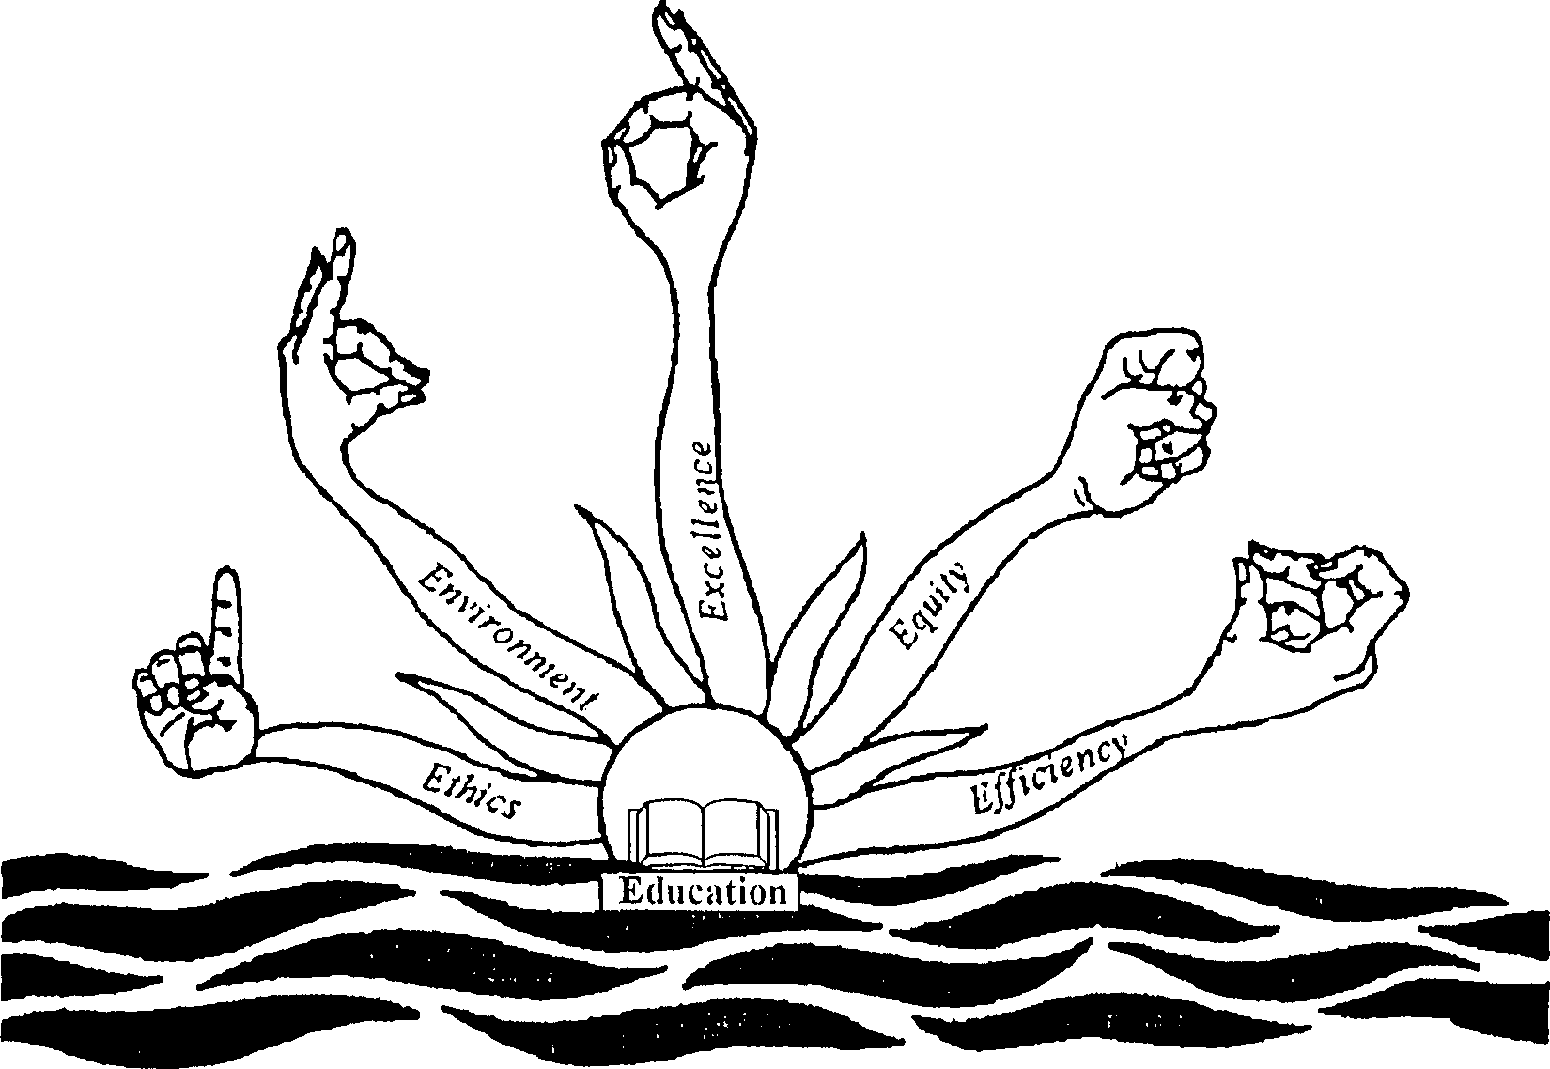
The Golden Triangle for Rewarding Creativity
Technological Institutional Educational
Formal Informal
Innovation
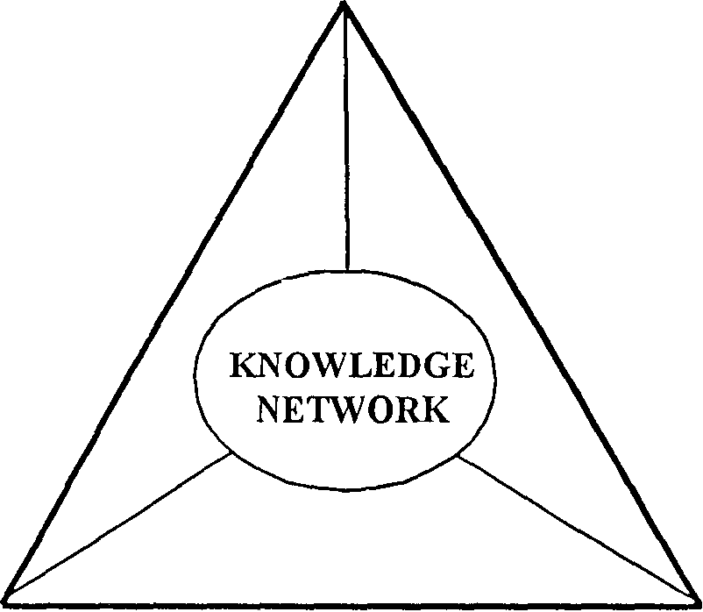
Investment Enterprise


Intellectual Material Financial

Ecopreneurship Social
Enterpreneurship

Once we know how the Access, Assurance and Ability and Attitude are organised, we must ask ourselves whether we want to reduce asymmetry in all the four vectors of sustainability at a time or only on one or two to begin with. Having decided that, we should identify the range of knowledge and information gaps that exists amongst the most efficient users of resources and the average users.
Mahatma Gandhi was once asked as to how did one begin rural transformation in any particular ' village. He mentions in Hind Swaraj that lie was not an expert on rural development. But lie describes what he would do, if he were to start. He would identify the most efficient and experienced person in whichever field one wanted to work in a given village. Thus, if one wanted to work with dairy fanners, one should identify the most knowledgeable and productive farmer. He would then identify the key production and management conditions used by that farmer. He would then do the same with some average fanners. The gap between the two would reveal the areas of intervention. This approach is called the benchmarking and best practice analysis in the modern management jargons. More than hundred years ago, Gandhiji gave us this management approach which we, of course, refused to follow in anything we do. For assessing the information needs we obviously therefore cannot give similar attention or weightage to the needs of the local experts or outstanding performers and the average producers. Likewise, we cannot assess the kinds of information people may like to share without looking at the ethical and cultural basis of local and external knowledge systems.
The next step therefore is to identify the local experts in various fields. The one who is an expert in climbing a tree to pluck coconuts may not be an expert in catching the fish or growing paddy or repairing a punctured tube of a bullock cart. Likewise, the people who innovate and who merely scale up existing innovations required different kind of information.
Having identified the needs which have to be responded in real time as against lliose which can be met offline, one has to choose an appropriate mix of media tools to reach the people. Much depends upon the basic conceptualisation of the Community Information Networks (CIN).
The CIN is an evolutionary process involving formal as well as informal knowledge exchange mechanisms. There are several other social networks which impinge upon CIN. For instance, any information embedded in kinship information network is likely to diffuse among the kinship networks faster than among those wlio arc outside it. Likewise, there are oilier cultural networks which are influenced by gender, age and other socio economic factors.
The application of Information Technology has to be considered after mapping various existing socio cultural networks and information exchange mechanisms in them.
There are five areas in which application of Information Technology can be assessed vis-a-vis the structure and processes of CIN;
- Information for emergency needs
- Information for scouting, augmenting and scaling up innovations
- Information for livelihood needs (Employment, health, education, etc.)
- Information for resource management, civic needs, recycling, etc.
- Information for socio cultural well being of the people as well as other non-human sentient being.

Paper presented at the Conference on Information Today and Tomorrow at Central Leather Research Institute, Chennai on 2nd September, 1998

