36
An Operational Framework for Developing Indicators of Sustainability
Anil K. Gupta*, P.S. Ramakrishnan** and K.C. Malhotra***
A regional workshop sponsored by UNESCO on Criteria and Indicators of Sustainability: A Natural Resource Perspective on Rural Development, was
organized in March 1999 at the Center for Management in Agriculture, Indian Institute of Management, Ahmedabad. It was decided to constitute a small group to discuss the operational framework for developing indicators comprising Professor P.S. Ramakrishnan, Professor K.C. Malhotra, and Professor Anil K. Gupta. This group met in July 1999 to develop the framework.
CONTEXT OF INDICATORS
An indicator provides an early warning signal about the impending changes in a system. Depending upon the level of aggregation and decision-making, different kinds of indicators would be appropriate for informing, influencing and intervening in a given system. Generally, the indicators that policy makers use may vary from the ones needed by the local communities or middle level resource managers. However, in a few cases, same indicator could inform all the levels. The Sustainability of a natural resource has to be determined in an inter-generational time frame. Yet it will be too late to wait for say, 50 years to know the implications of any policy change. Thus, assumptions are made about the Sustainability implications and accordingly indicators are developed for measuring the movement of an organization or a resource-managing community along that path.
A good set of indicators for a community would be those which address the priorities of a community recognizing heterogeneity in articulating priorities by the community. The framework should enable different socio-segments to draw up appropriate meanings which may or may not converge. In such a case, indicators can also provide an articulation of the different perspectives of the Sustainability itself.

-------------------------------------------------------
*Indian Institute of Management, Ahmedabad.
* Jawaharlal Nehru University, New Delhi.
***Indian Statistical Institute, Calcutta.
422 Criteria and Indicators of Sustainability in Rural Development
Indicators of change in an unstable system under stress would be different from a system which is highly homeostatic in nature. In the former case, the coping strategies of the community would be diversified and often precariously balanced. In the latter case, the strategies may have redundancy and yet would require specialization. A small change in either of the systems if not noticed at an early stage may amplify to different extents and through different pathways. The framework of analysis should enable the decision makers to understand these trade-offs and estimate the cost of not responding to an early warning signal. The ecological indicators would obviously differ from socio-cultural and institutional indicators at the micro and macro level.
THE CATEGORIZATION OF INDICATORS
- Intensity
- Frequency (regular, irregular; predictable or unpredictable)
- Level (micro or macro)
- System characteristics (socio-cultural or socio-economic, ecological, institu-
tional)
- Coverage of indicators (what is the domain of application, whether valid
for a specific location or generalizable in nature)
(f) Analogic or digital indicators (the former refer to metaphorical while the
latter imply empirical and generally measurable)
In a day-long discussion it was not possible to do justice to all the dimensions. However, it was recognized that some common currency is required to measure the intensity and frequency of indicators. Events like drought are uncertain over time, but risky over space. We do not know when they will occur but we can estimate the probability of the place where drought is likely to occur most. The distinction is also required in terms of repeatability of an event as well as the intensity of the same. For instance, a stress food which serves as an indicator of drought in a particular year may not indicate the same in subsequent years due to internal or external reasons.
Different indicators need to be validated and standards have to be developed to check the validity (this issue was not discussed adequately at length). The validation by the local communities takes place through repeated use over a long period of time whereas scientists might like to look for causal connections.
Attributes of an Indicator
(a) Indicators of Renewability/Regenerability
Renewability could be through natural or human induced regeneration. The requirement of energy subsidy may be a good indicator of the renewability. Higher the subsidy required, lower the renewability of the system and vice versa. For instance, a recuperation of a well may indicate the status of ground water. A nature of ground water use system may suggest the kind of recuperation capacity. For instance, a region having more large-size open wells may have
An Operational Framework for Developing Indicators of Sustainability 423
no recuperation capacity whereas another region having tube wells may have higher recuperation capacity.
(b) Redundancy
This is captured by diversity of the system. Inter-species and intra-species diversity may capture different dimensions of ecosystem flux and resilience. For instance, biodiversity may be an indicator of Sustainability.
(c) Resilience
There are two kinds of homeostatic properties, developmental and physiological. The former refers to the adaptation over time. For instance, we lose our hair or teeth in our old age and senescence in trees. The perspiration after heavy work in humans or regulation of stomatal movement in plants indicate the latter. The resilience can also be measured by the redundancy. However, it has to be remembered that too much of redundancy in a system can create inertia and too little can cripple. Optimal redundancy has to be worked out for each system.
(d) Diversity
It captures both the properties of renewability and resilience. In biological terms, higher the diversity of alleles at a particular locus greater may be the possibility of long-term survival of population. In socio-ecological terms, diversified portfolio of resources and skills generates greater resilience and renewability of a resource, provided institutions for self-regulation exist.
(e) Complexity
The inter-relationships among different components of a system may be much more complex in one context than another. For example, the fishing prospects in an offshore turbulent sea may be a very complex phenomenon and yet local fishing communities evolve thumb rules to deal with the same.
The cross system perturbation also manifests in the case of fishing much more than perhaps in other systems. The siltation/pollution from the rivers or other effluents may affect turbidity which in conjunction with wind velocity and direction, cloudy or clear sky and temperature variations at different levels in the sea may affect the movement of fish schools.
(f) Location Specificity
The variation in terrain, soil fertility and structure and agro-biodiversity creates unique niches in conjunction with micro-climatic conditions. The resource-use practices have to be adapted to such locations. One has to, however, recognize that higher the fit of an indicator with location specificity, lesser may be its generalizability. The trade-off does not have to be between what we call external and internal validity. The former refers to generalizability and while the latter refers to its internal consistency it measures what it is supposed to measure. However if an indicator performs more accurately at a given location but fails to do so across the regions, then it will lose its external validity.

424
Criteria and Indicators of Sustainability in Rural Development

The 4A framework (Gupta, 1995) tries to link Access, Assurance (horizontal, about others' behaviors vis-a-vis one's own, and vertical assurance about future returns from present investment), Ability and Attitudes about ecological context. It helps in appraising sustainability of any intervention or project by looking at its viability on four vectors.
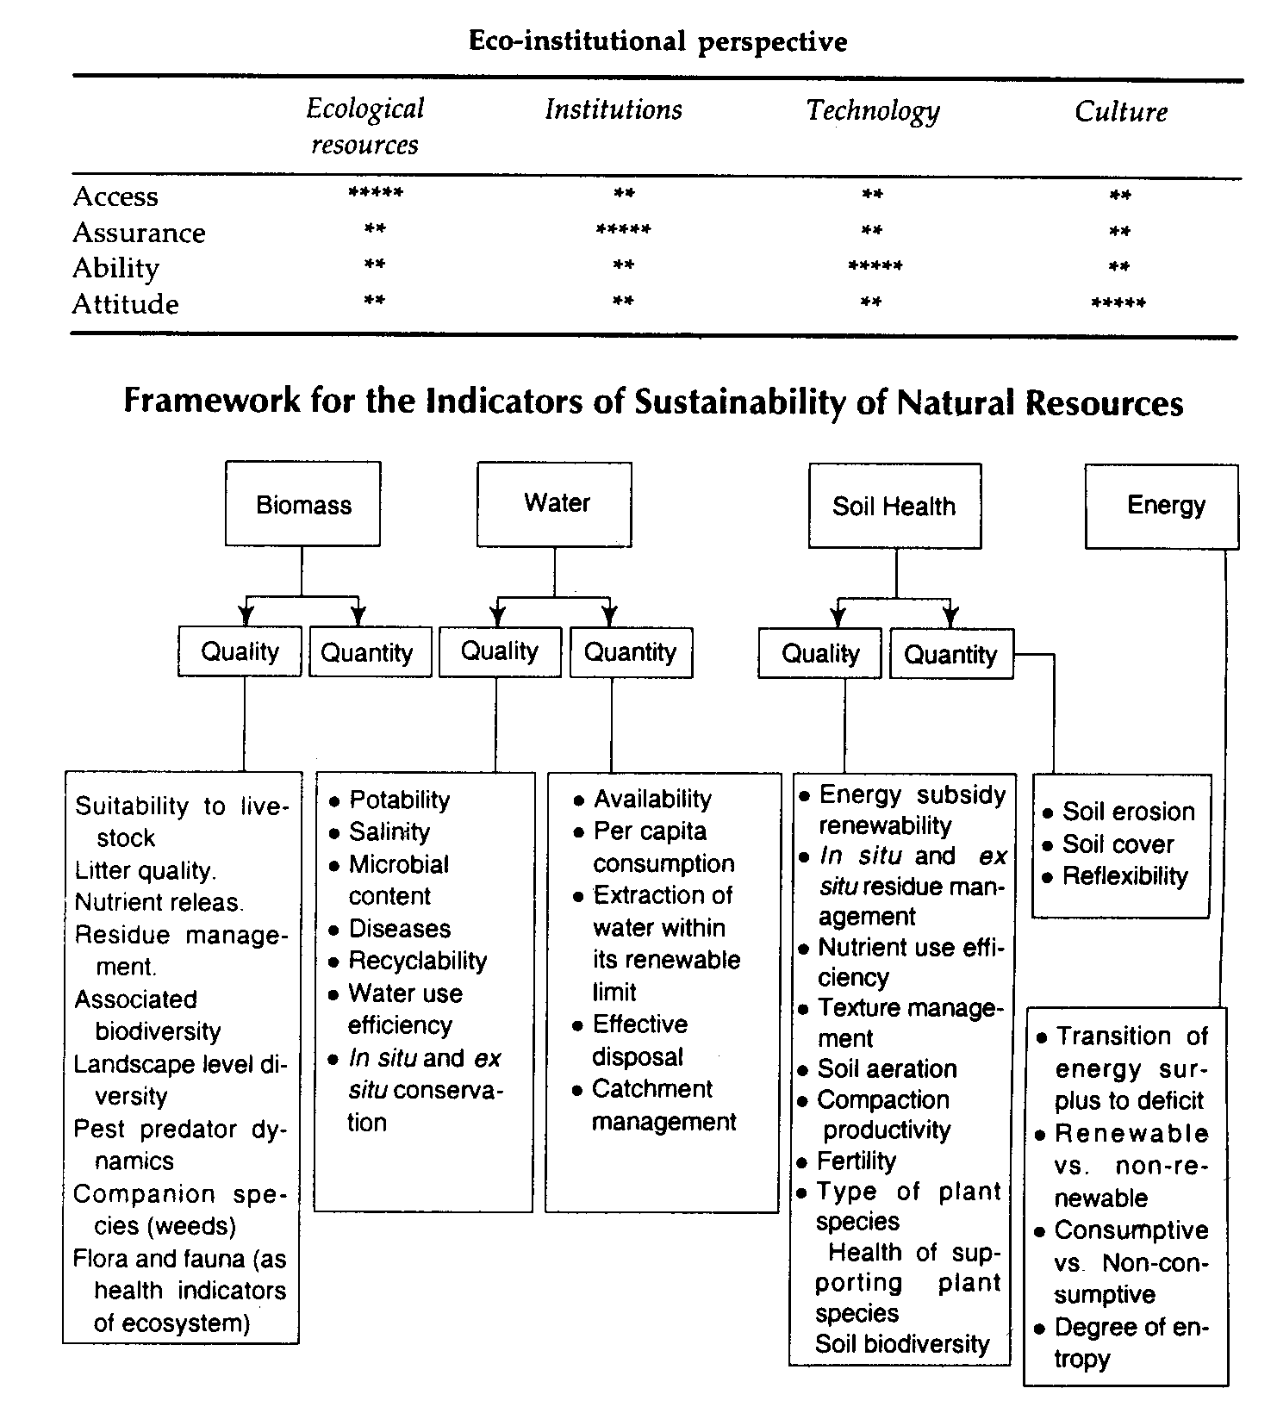

REFERENCE
Gupta, Anil K. 1995. Sustainable Institutions for Natural Resource Management: How Do We Participate in People's Plans. In: People's Initiatives for Sustainable Development Lessons of Experience, Syed Abdus Samad, Tatsuya Watanabe and Seung-Jin Kim, (Eds.) Asian and Pacific Development Centre, Kualalumpur, Chapter 15, pp.
341-373.

